

**V10-MATERIAL MASTER**

**REQUESTOR ROLE**

Copyright PiLog India Pvt Ltd

**Rights to the contents of this document**

This document contains proprietary information belonging to PiLog India Pvt Ltd. It may not be reproduced without written permission. Disclosure of the contents of this document to third parties is strictly prohibited. The information in this manual is correct at the time of printing.

**Table of Content**

1. Search 4

1.1 Introduction of Smart Search 4

1.2 Dictionary and Classification Search 6

1.2.1 Dictionary Search 6

1.2.2 Classification Search 8

1.3 Parametric Search 9

1.4 Category Search 13

1.5 PiLog Repository 15

1.6 Results 16

1.7 Template Results 17

How to Register a Material 19

Characteristics 20

Reference Data 21

Documentation 21

Attachment 22

SAP Data 22

Description 23

Additional Text 23

2. Registrations 25

2.1 Pending Registration 27

2.2 Returned Registrations 28

2.3 Registrations Marked for Deletion 30

3. Extensions 32

Overview of Material Extensions 32

3.1 New Extensions Requests 34

3.2 Pending Extensions 36

3.3 Returned Extensions 37

3.4 Extensions Marked for Deletion 39

4. Change Requests 41

Overview of the Change Request Process 42

4.1 New Change Requests 42

4.2 Pending Change Requests 45

4.3 Returned Change Requests 46

4.4 Change Requests Marked for Deletion 48

5. Deletion Requests 51

5.1 New Deletion Requests 51

5.2 Pending Deletion Requests 53

5.3 Returned Deletion requests 55

5.4 Deletion Requests Marked for Deletion 56

6. Undeletion Requests 58

6.1 New Undeletion Requests 59

6.2 Pending Undeletion requests 61

6.3 Returned Undeletion requests 62

6.4 Undeletion Requests Marked for Deletion 64

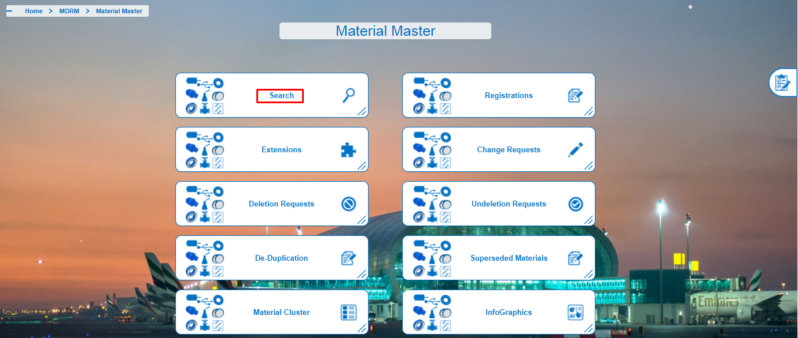

# 1. Search

## 1.1 Introduction of Smart Search

The purpose of Smart Search is to serve as a general search. This search method is used to search on Class names, Characteristics value, Part numbers, or any other information available in the material record.

Smart Search can be performed with beginning, containing and ending characters, with full or part of word or number.

* The Search facility can be accessed by all users and the search functionality is the same for all users.
* Type the keyword which you want to Search from the PiLog Catalogue. For Example If you want to see the Descriptions and the items of VALVE, Just type the word VALVE and Automatically all the Descriptions will be displayed.
* Click on the Description then we can get the complete information of the item.

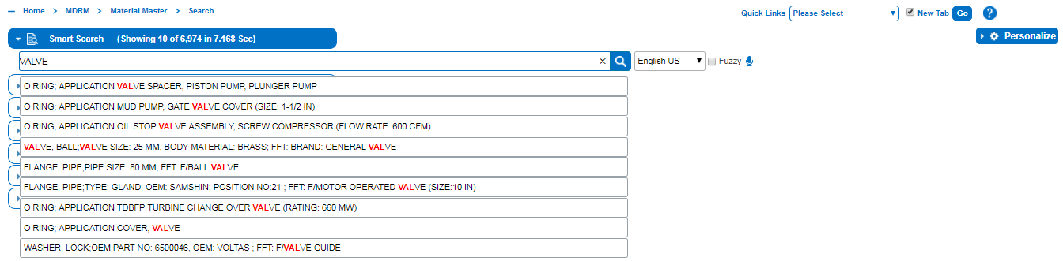

**Figure 1.1: Example of Smart Search Tab**

* Click on the Description as shown (fig 1.1), then we can see the item in the Results Tab.

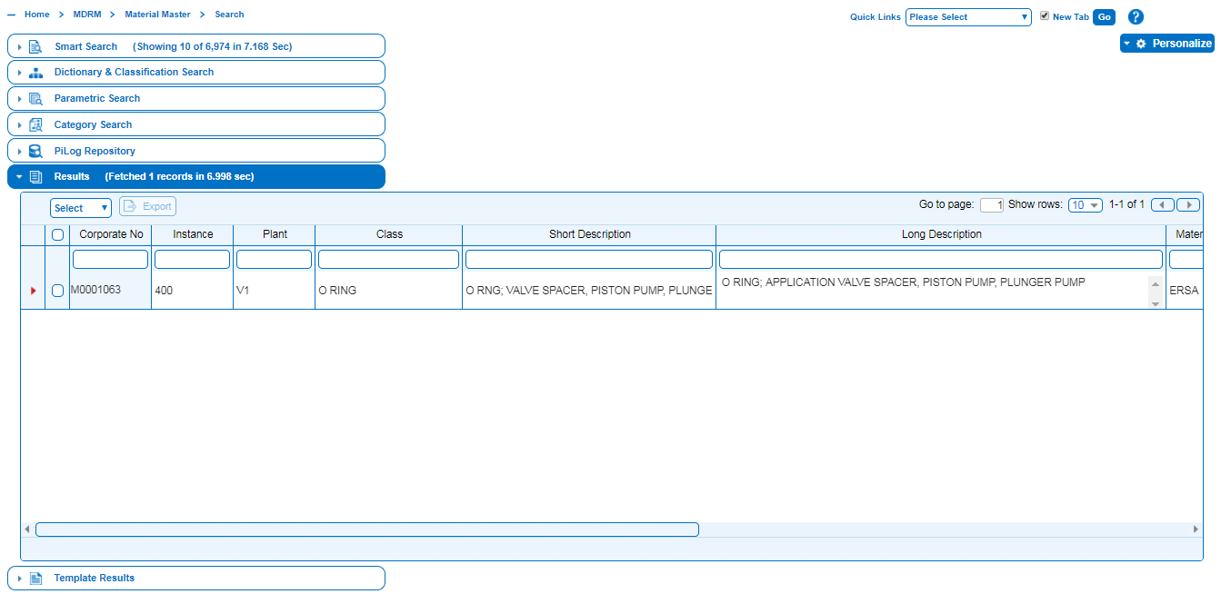

* If we want to retrieve all the Bearing Items which already exist in PiLog Catalogue then click on Search icon  Button to get all the results.

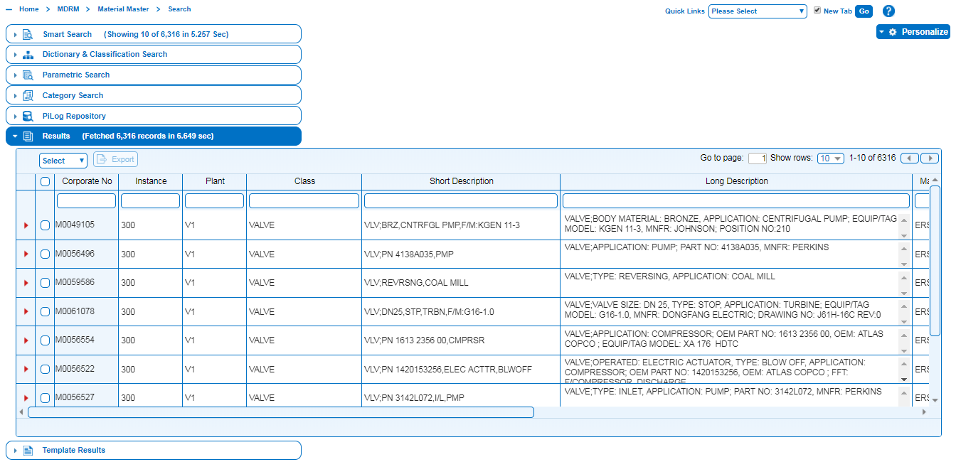

## 1.2 Dictionary and Classification Search

### 1.2.1 Dictionary Search

Dictionary Search function performs a detailed search on the class name including the list of characteristics value to select values for search in the material master.

Search shows the free text box to provide criteria (class name). Class name templates that match with search criteria are listing down the search text box. Click on the class template opens the characteristics of it.

* Fill the property value to search or click on the magnifier towards the value opens the values list to select the value from it.

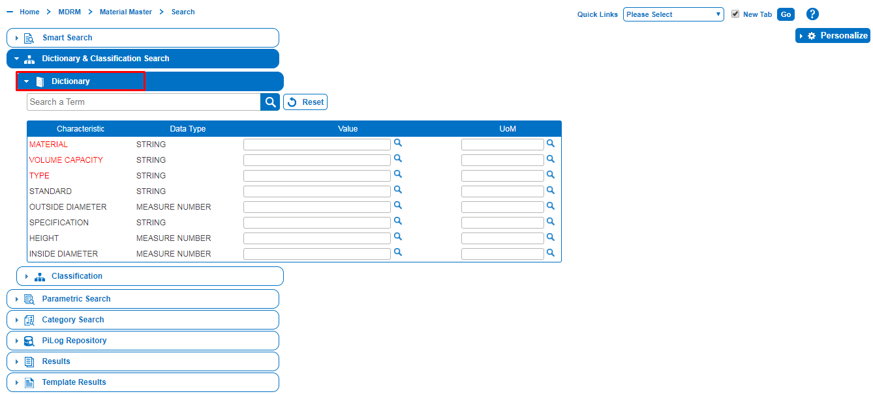

It can be added to Search list from the Personalize list box.

* Smart Search opens once click on Search menu and Personalize button shows on the right side. Click on the Personalize button.
* Personalize list box opens, shows all the search types.
* Click in the Display check box towards the Dictionary & Classification Search.

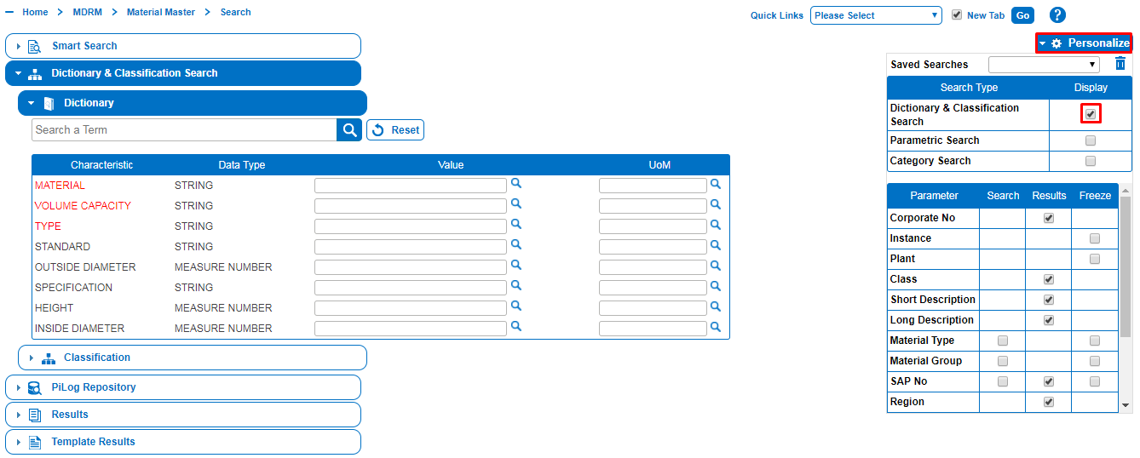

# 1.2.2 Classification Search

The Classification search is used to search for any linked material record through a pre-defined classification structure. A classification code must be linked to a record in order to use this search method.

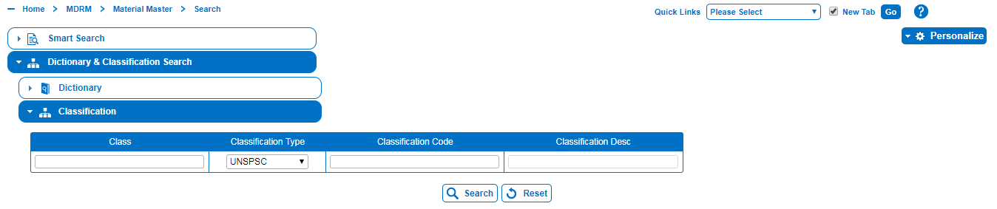

* Click on Classification Search tab.
* Classification search tab opens the search fields.
* Click in the Classification Type to display the list box. Select the appropriate classification code from the list box.

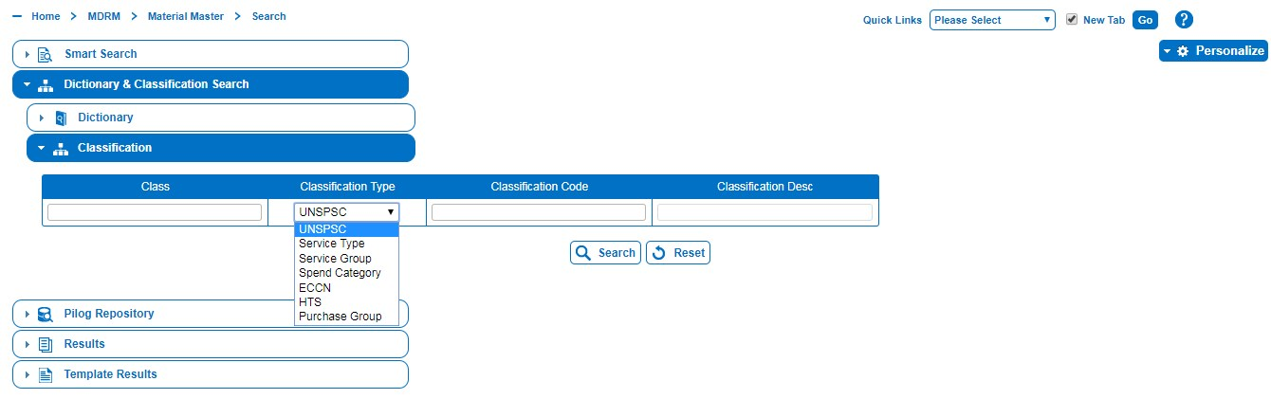

* Click on Search button to fetch the results.

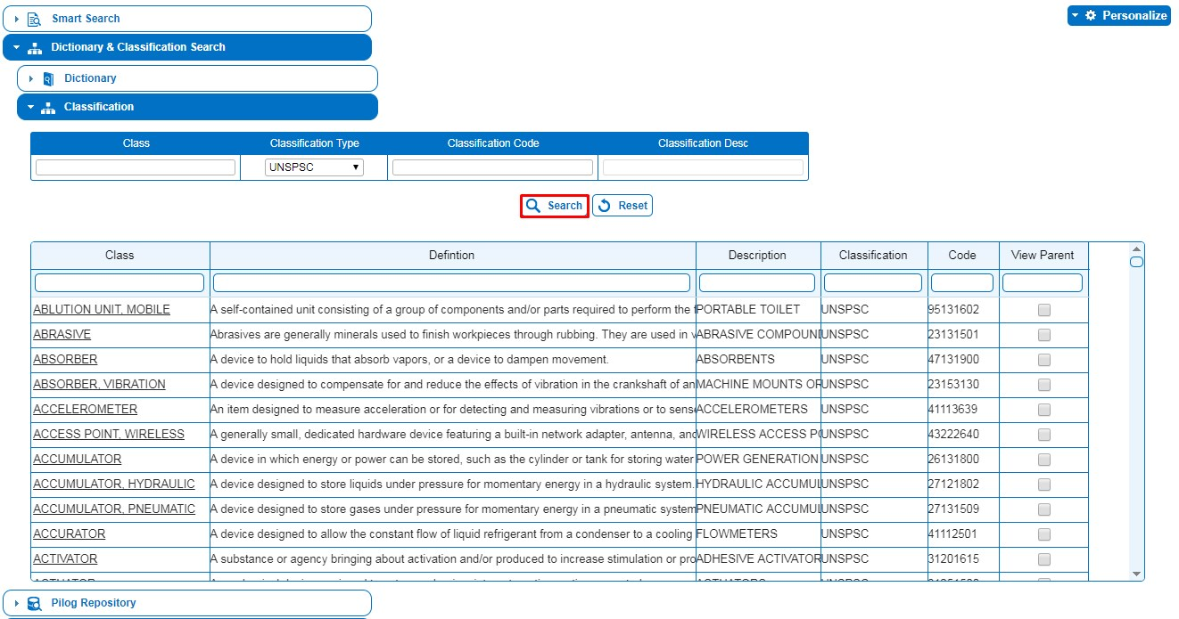

# 1.3 Parametric Search

This search function consists of various fields use to specify the search criteria to identify particular materials in the material master. It can search on one or more fields.

Some fields provide retrieval popup windows from where a user can select one or more criteria to search with.

* The Search facility can be accessed by all users and the search functionality is the same for all users.

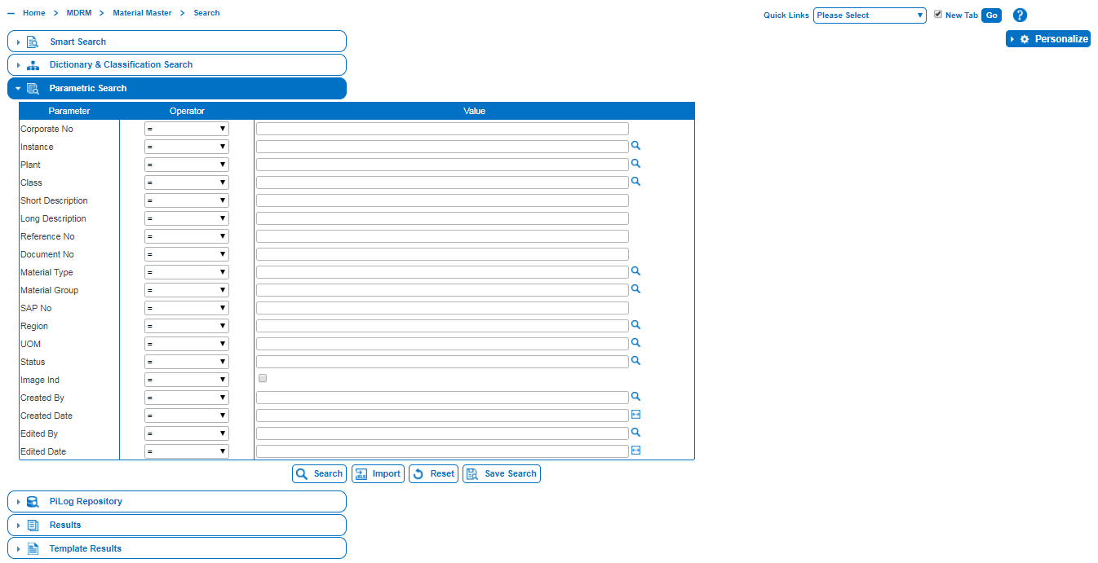

**Table 1: Search Criteria**

|  |  |
| --- | --- |
| ***Search Criterion*** | ***What the Search Engine searches on*** |
| Corporate No | Searches for records On the Specified MDRM number, or range of MDRM numbers. |
| Class | Searches for records on the specified Class Name.  For Example: Ball, Bearing, Valve, O-ring |
| Short Description | Searches for records on the specified short Description.  For Example: BLT... |
| Long Description | Searches for records on the specified Long Description.  For Example: BELT... |
| Region | Searches for records on the specified Region |
| Status | Searches for records on the specified Status |
| Created By | Searches for records that’s been created by a specified user |
| Created Date | Searches for records created on a specific dates. |

* Click on Parametric Search, search criteria will be displayed.

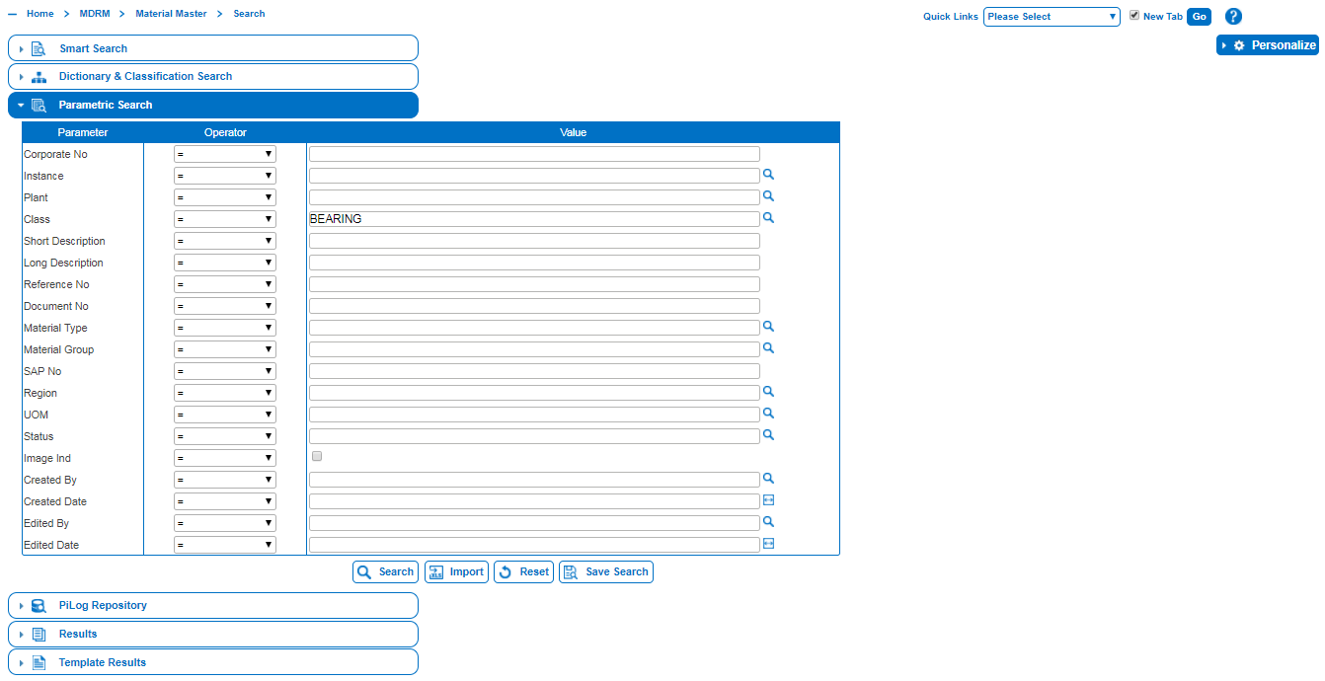

* Click on search to display results.

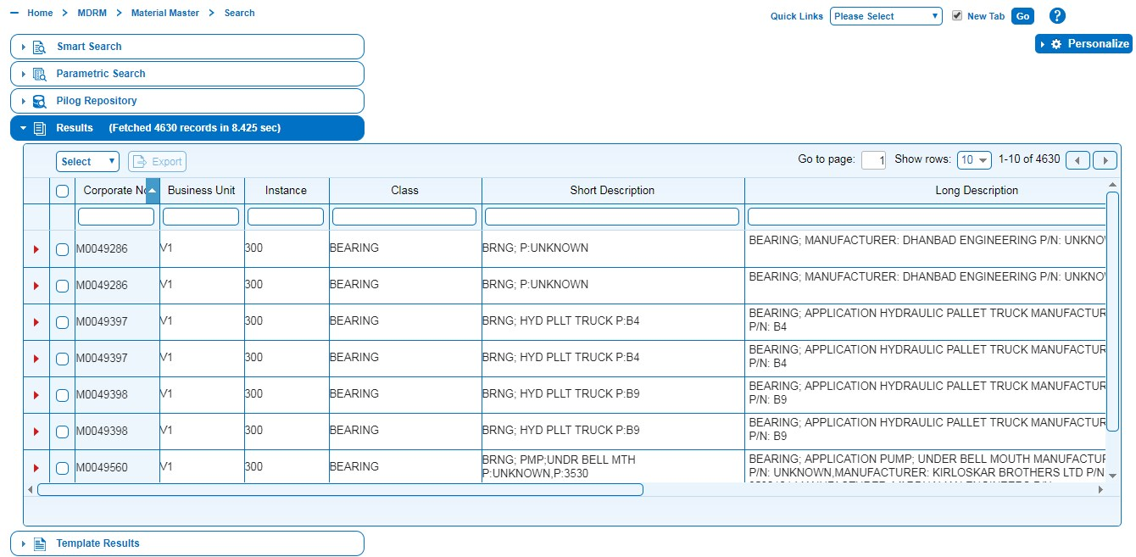

1. Default Display criteria are Corporate No, Class, short Description, Long Description, Material group, Region and Status.
2. Default Freeze column is Corporate No.
3. By using Filter option, can filter the result.

Search facility provides users to change Search criteria, Results and Freeze Columns by using **Personalize** function.

1. Click on Personalize  to change criteria.
2. Select fields from Search criteria, Results and Freeze Columns.

**Note**: Selected criteria fields from Personalize will be added to default criteria fields

|  |  |
| --- | --- |
| ***Search Criterion*** | ***What the Search Engine searches on*** |
| Corporate No. | Searches for records on the specified Corporate No. |
| Class | Searches for records on the Class. |
| Short Description | Searches for records on the Short Description |
| Long Description | Searches for records on the Long Description. |
| Material Type | Searches for records on the specified Material Type |
| Material group | Searches for records on the specified Material Group |
| Region | Searches for records on the specified Region |
| Status | Searches for records on the specified status |
| Image Ind | Searches for records on the specified Image Ind |
| UOM | Searches for records on the specified UOM |
| Part No | Searches for records on the specified Part No |
| Reference No | Searches for records on the specified Reference No |
| Created By | Searches for records on the specified Created By |
| Created Date | Searches for records on the specified Created Date |

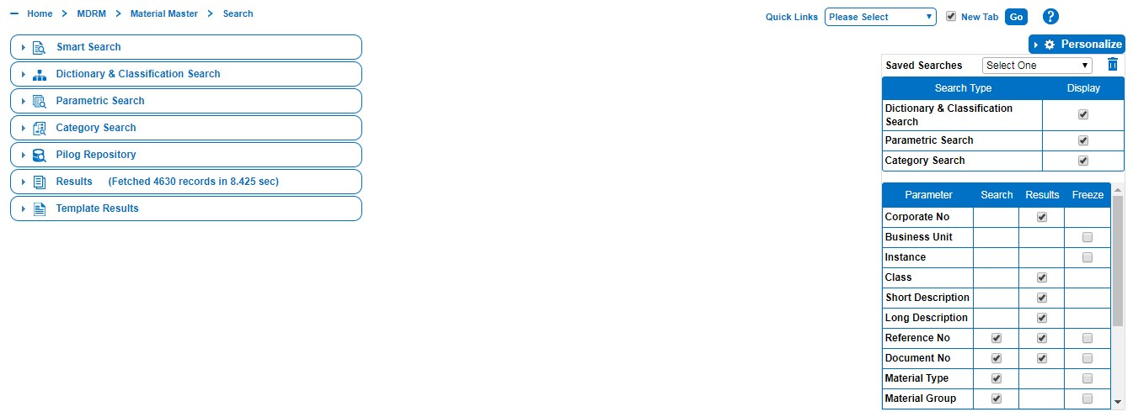

## 1.4 Category Search

The category search allows users to select a category which will return the classes grouped under each category which allows the user to select one or more relevant classes and the search will return all relevant records that are linked against the specific class.

* This facility allows to search for the material records according to the type of industry such as Mining, Oil & Gas, Automobile, etc. and Category wise such as Electrical, Drilling, Instrumentation, Food & Beverage, Tools, etc.

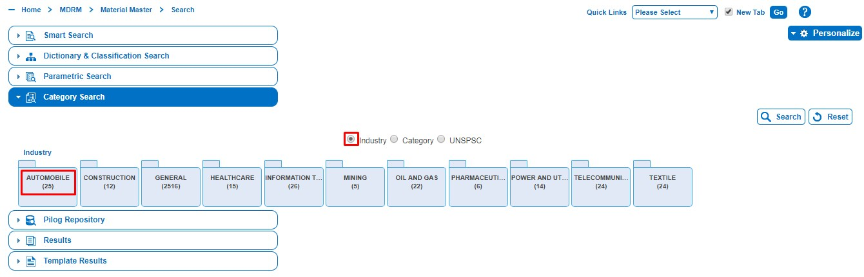

* Industry tab shows all types of industries in folders and displays the number of industrial types associated with each industry.

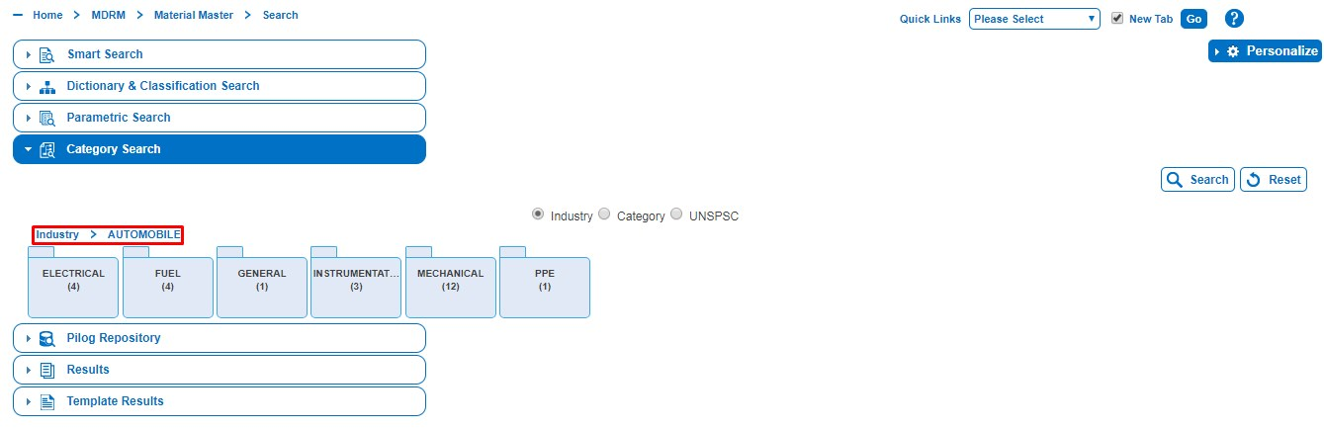

* Click on any category opens the material classes linked to each. For example: ELECTRICAL.
* Multiple classes can be selected by clicking in the select check box.

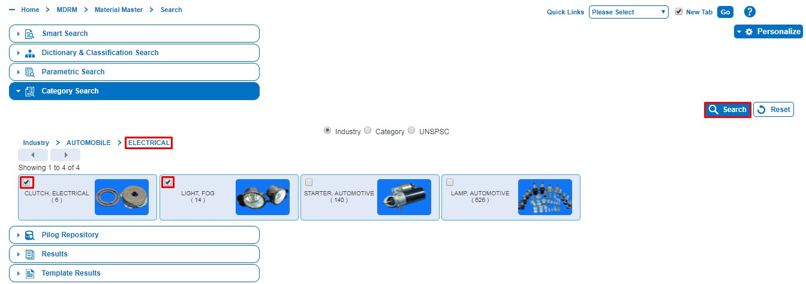

* Click on Search button to open the material records linked with the selected classes.

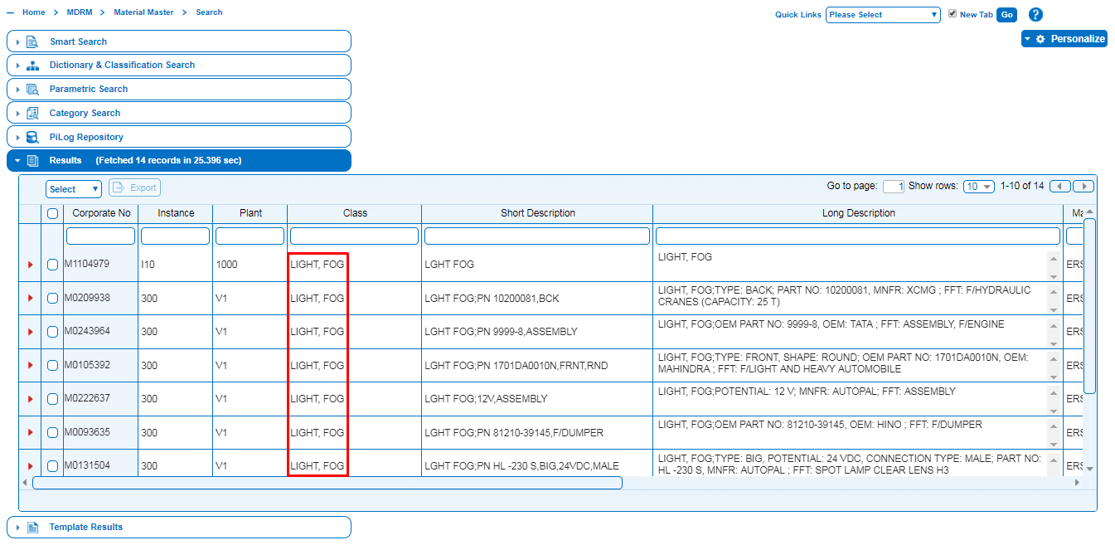

Category search helps to search materials records according to its category.

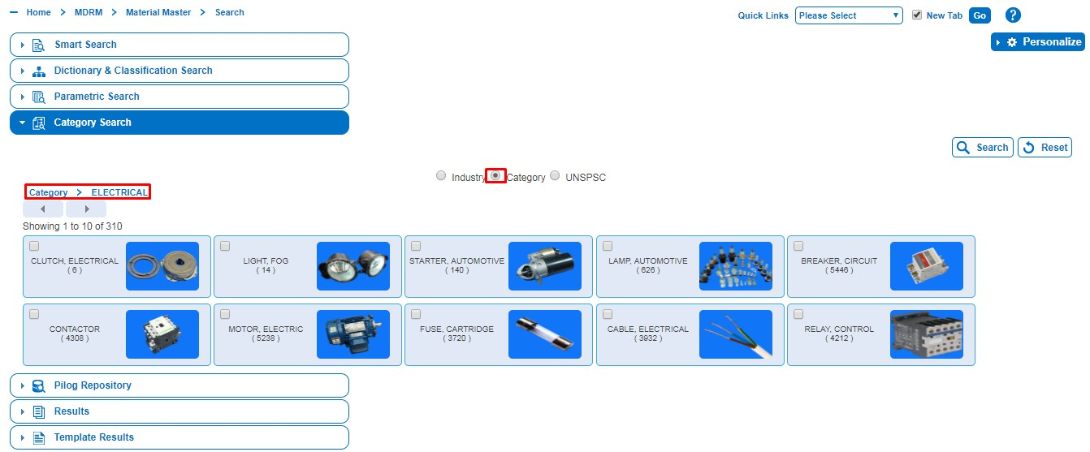

## 1.5 PiLog Repository

This search function searches the records in the PiLog Preferred Record (PPR) contains the ‘golden record’ in the PiLog data bank. It facilitates to search by Reference No (Part number), Class, Vendor Name & Description which will bring the results that contains the search criteria in anywhere in the PiLog Preferred Record.

* This search type allows searching with multiple search criteria like Reference No, Class, Vendor Name and Long Description fields.
* Fill in the search criteria in the respective field. For example: search for the records where class match with.

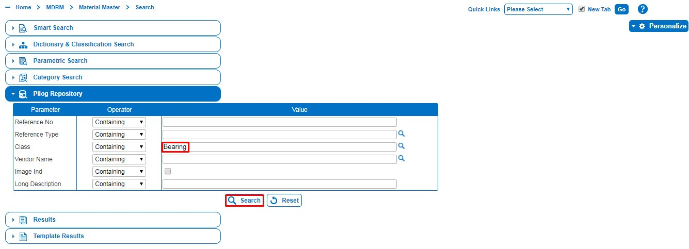

* Click on Search button to search for the records in the PiLog Repository.
* Results tab opens, shows the results match with search criteria.

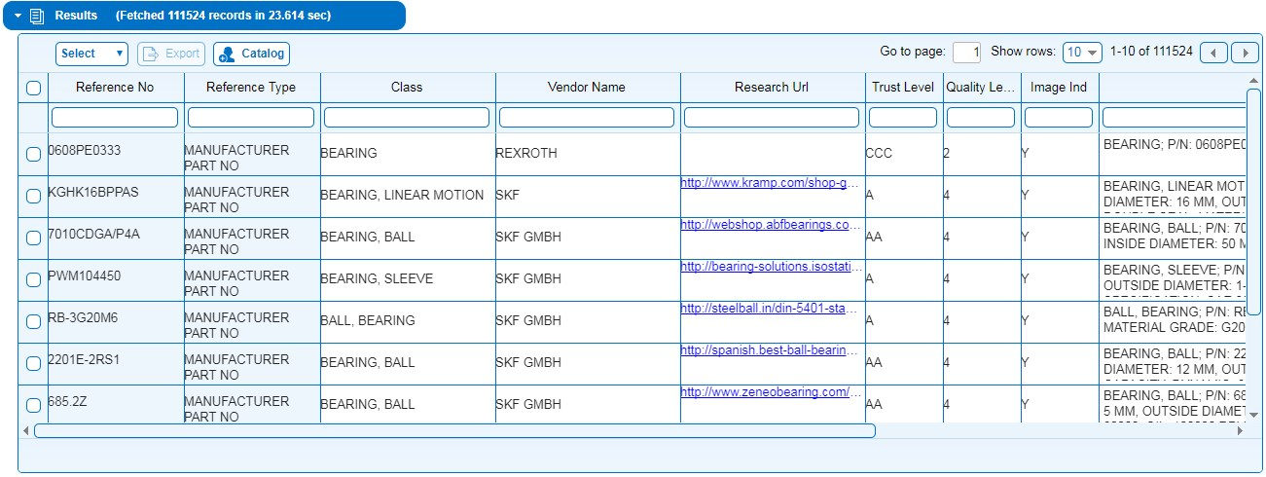

## 1.6 Results

Results page may have multiple pages. Page navigation functions become active when more than one page of results is available.

* Results label shows the total number of records fetched and also shows the time consumed to fetch the records.

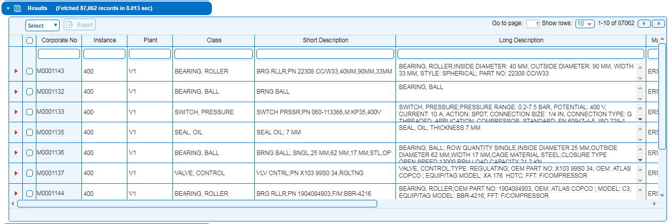

* The Report displays the Corporate Number, Plant, Instance, Class, Long and Short Descriptions for Selected record.
* If we want to retrieve all the Bearing Items which already exist in PiLog Catalogue then click on Search icon  Button to get all the results.

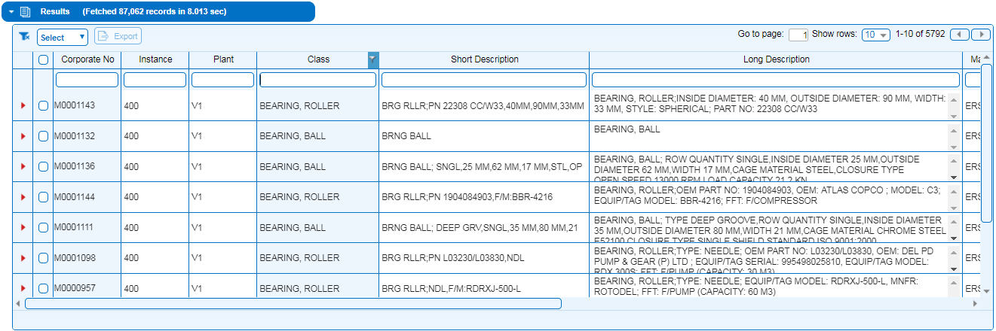

## 1.7 Template Results

* Click on the Description as shown (fig 1.1), then we can see the item in the Template Results Tab.
* The Report displays the Image, Class, Record Count and Definition for Selected record.

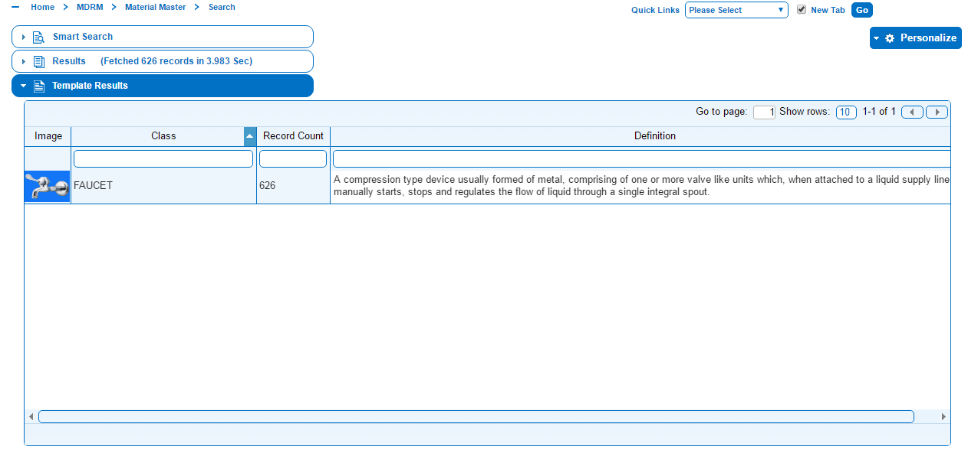

**Figure 1.13: Template Result Tab**

* If there are no records for the term Searched then we can see a message as below.

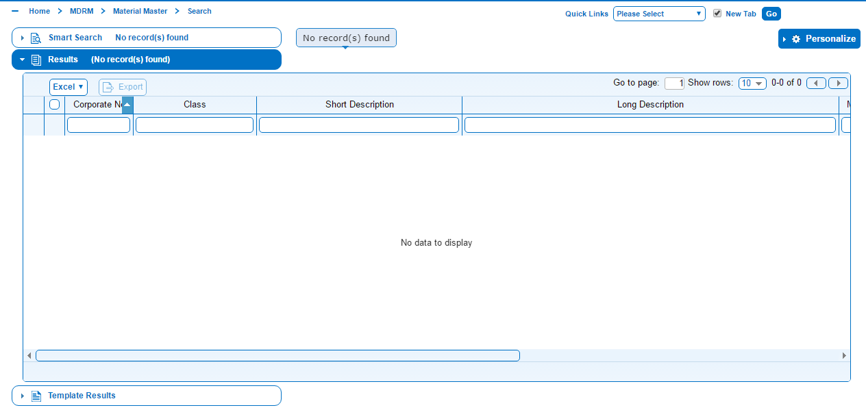

**Figure 1.14: Example of No records found**

## How to Register a Material

* Click on the Search Tab as shown in Fig (1.1) and type the class name to create. Once you start typing the class name, all the classes will be displayed in the List Box. Select the Required Class, Class will be displayed in Result tab and Template results Tab. If you click on Class then new registration tab open in next page.

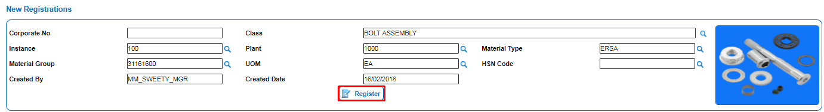

* Click on registration  button. A pop-up message will be displayed as “Registered Successfully”.

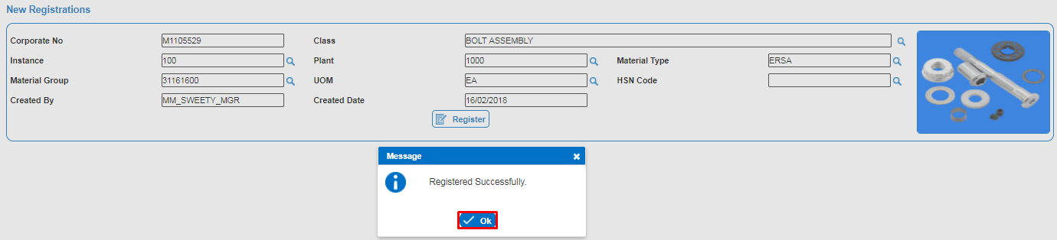

**Figure 1.16: Material Registration Tab2**

* After registered successfully you will get a new tab as shown in bellow figure.

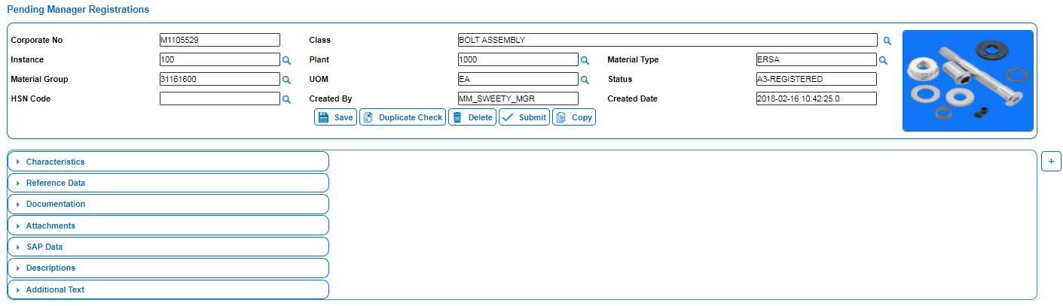

### Characteristics

* Click on Characteristics Tab, Fill all the fields and click on Update Button to update.

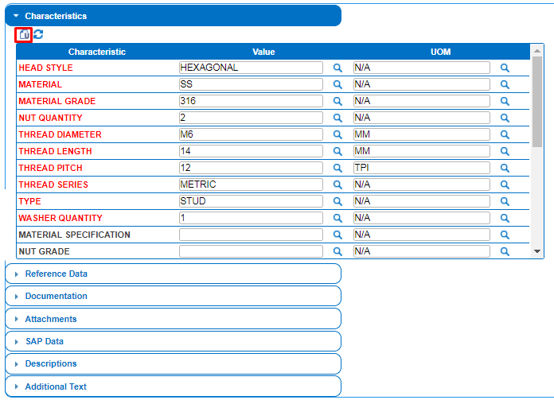

**Figure 1.18: Characteristics Tab1**

* Characteristics tab shows Characteristics, value, UOM, Required.
* Mandatory properties will be in Red colour which needs to be filled compulsory.
* After filling all the values you can click on update button to update the values you will get a message “Updated Successfully”.

**Figure 1.19: Characteristics Tab2**

### Reference Data

* Fill all the fields in the Reference Tab and click on update Button to save.

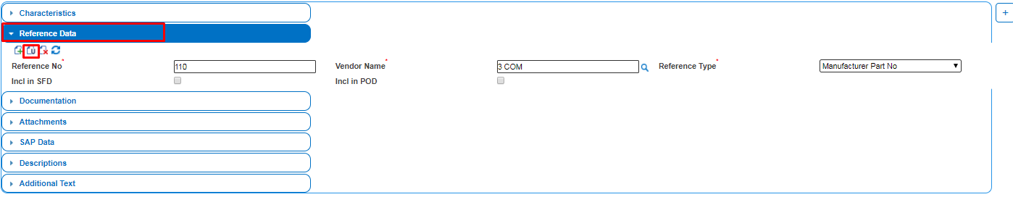

* After filling all the values you can click on update button to update the values you will get a message “Updated Successfully”.

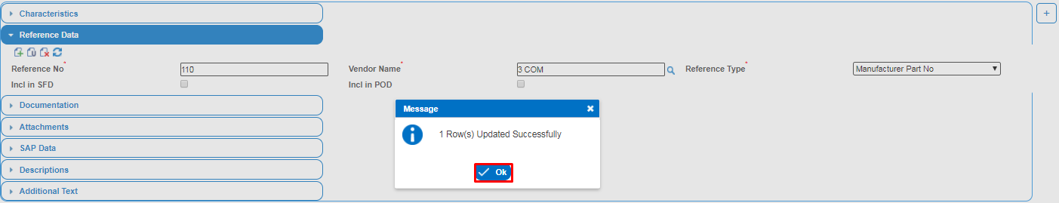

### Documentation

Documentation such as Document Number, Vendor Name, Document Type, etc... can be added to material description.

* Fill all the fields in the Documentation Tab and click on update Button to save.

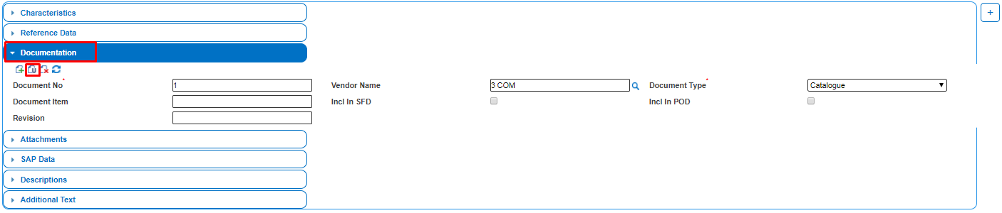

* After filling all the values you can click on update button to update the values you will get a message “Updated Successfully”.

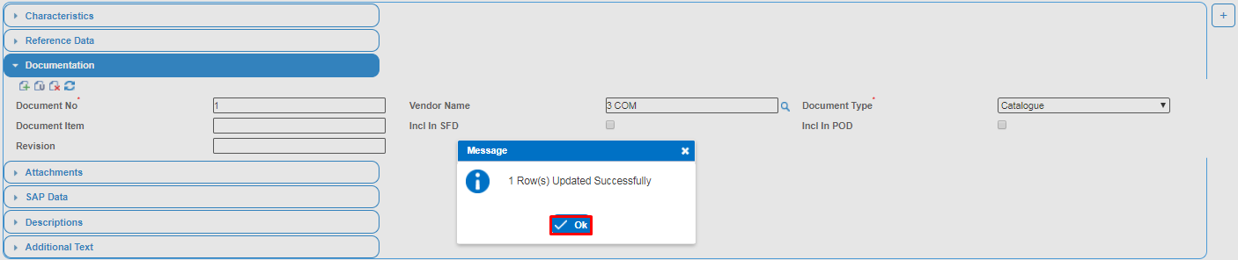

### Attachment

* Click on Image Attach icon, Select one image from desktop and click on Open button then will see one image in attachment tab.
* Attach drawings, catalogue, image and Document.

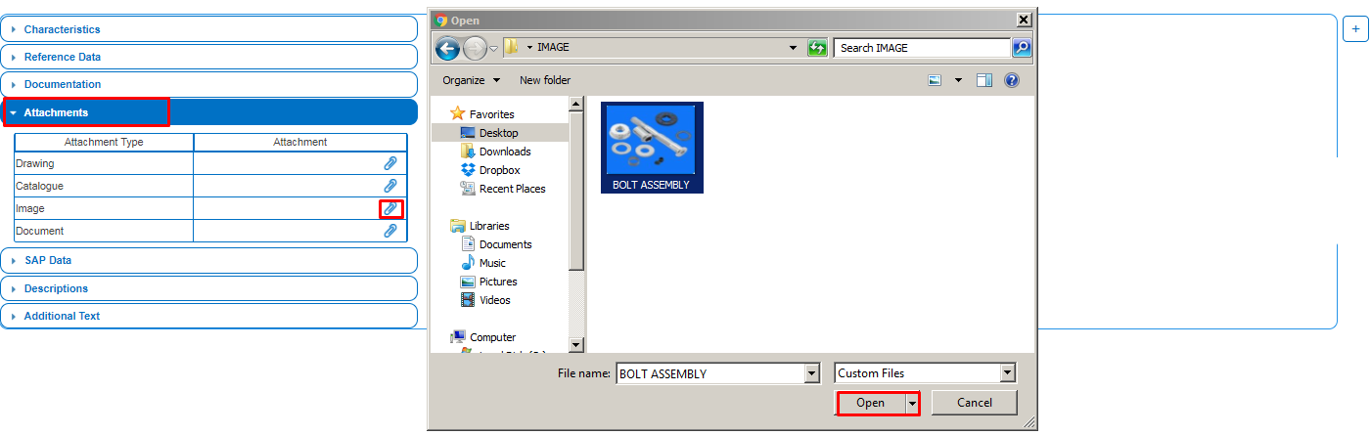

### SAP Data

* The SAP Data tab is used to specify the data required by the SAP for the material record. This tab shows various tabs such as Basic Data, Purchasing, Foreign Trade, MRP, Forecasting, Plant Storage, Accounting, Warehouse etc...
* Once all required details filled, and then click on update icon to save.

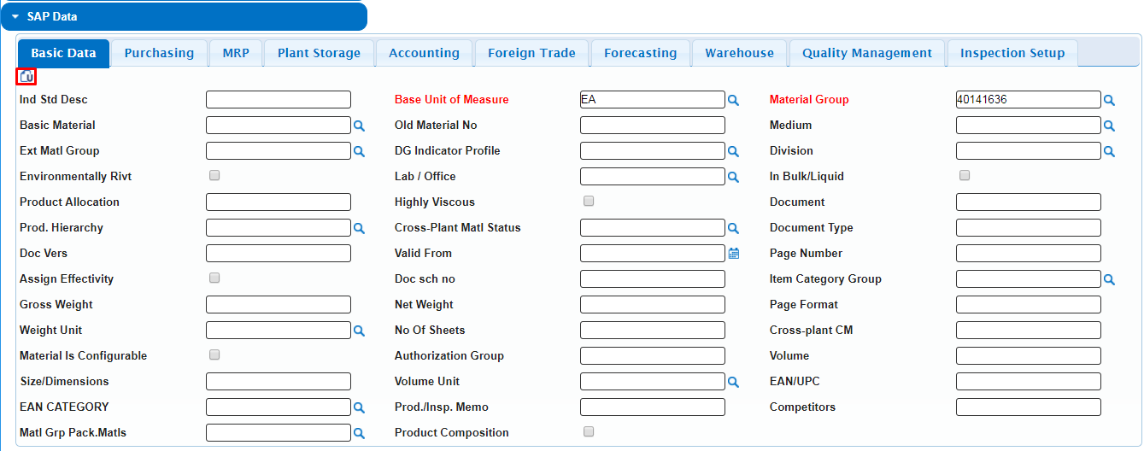

### Description

There are Four types of Descriptions are generated automatically when a tab is updated. All the material info populated under various tabs.

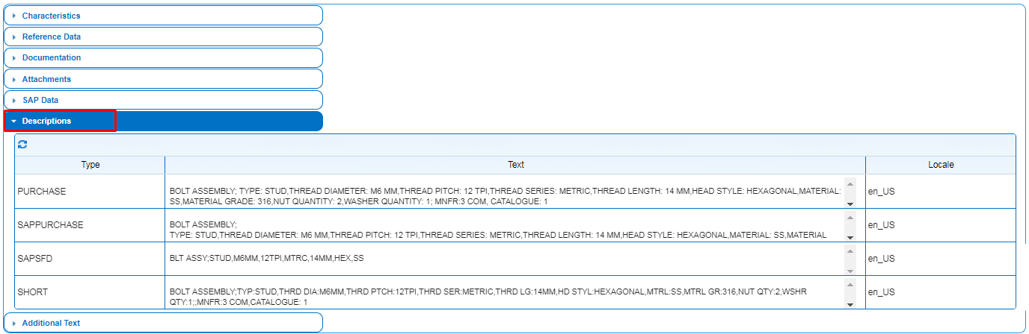

### Additional Text

This tab is used to add additional information into the purchase order description than what the Characteristics tab and other data tabs provided. When you select this option, all data entered in the Text field towards Additional info will be appended to the Purchase Order Description.

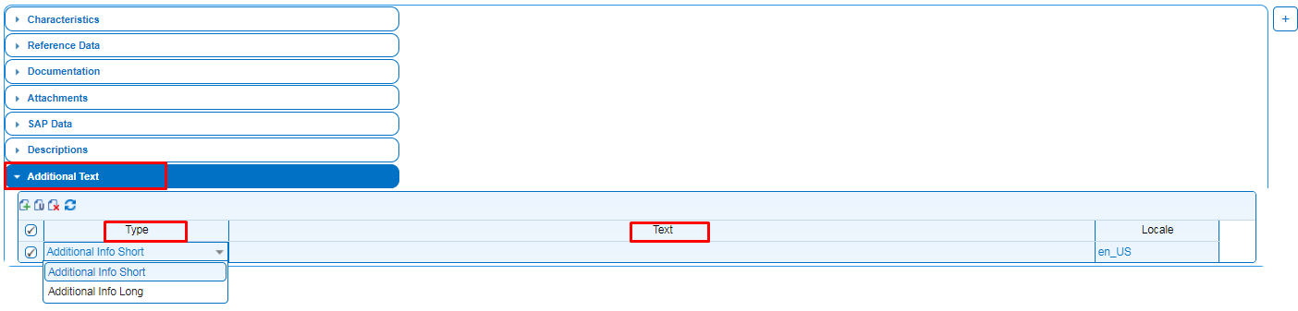

* Finally you can save the record by click on the Save button.

**MATERIAL CREATION REQUEST STATUS FLOW:**



# 2. Registrations

The Material Registration facility provides the users with a utility to request for material registrations, track, and rework; and delete material registrations.

The Material Master is the database where material data is stored. The new material data becomes part of the information that will be used in other material record management processes such as the generation of descriptions, searching and finding material records, tracing possible duplicate records and so on.

The various processes in the PiLog-MDRM are managed by means of the status of a record. When a new record is created a particular status is allocated to it (such as “A1-REGISTERED”).

The process for Requestor is basically as follows:

* Search for a material record.
* Register a material record. Registration process consists of Identifying the Class of the material. Identifying and filling all mandatory and optional characteristics values of material, adding reference data, attachments and descriptions and also duplicate check process.
* Submit new records for approval by an approver.
* Rework material records returned by the Approver and/or Steward.
* Delete an unwanted new material record.
* Reinstate a material record.

Following is a graphical representation of the process Requestor follow to register Material in PiLog-MDRM™.

Click on the Registration Tab.

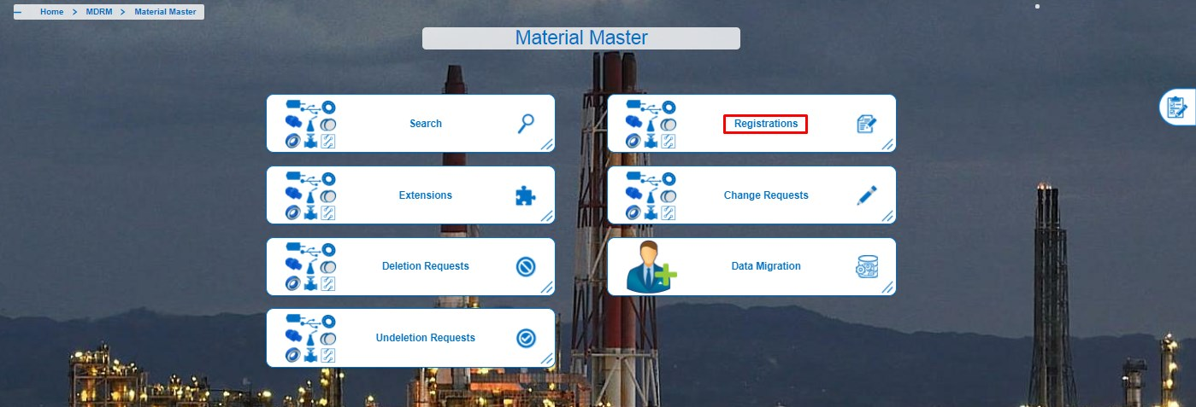

**Figure 2.1: Registration Tab**

## 2.1 Pending Registration

The requestor can retain the Material items that he/she created, if it is not completely finished. The Material items which are registered and not submitted for approval are fetched in the Pending Registrations tab.

For Submitting Pending Registrations to Approver comprises the following step:

* Click on Pending Registrations from Registrations Module.

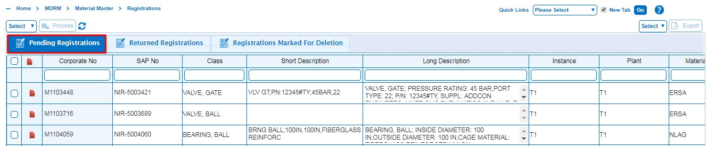

* Click on Corporate No to retrieve the Corporate Number.

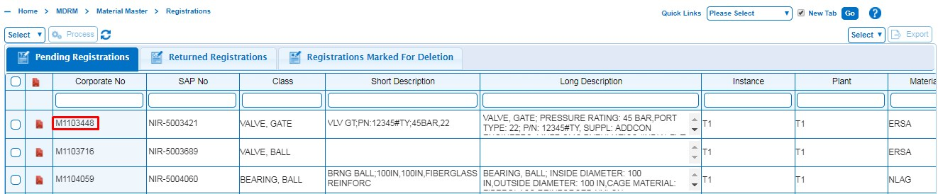

* Make the required changes in Tabs for new registration if needed.

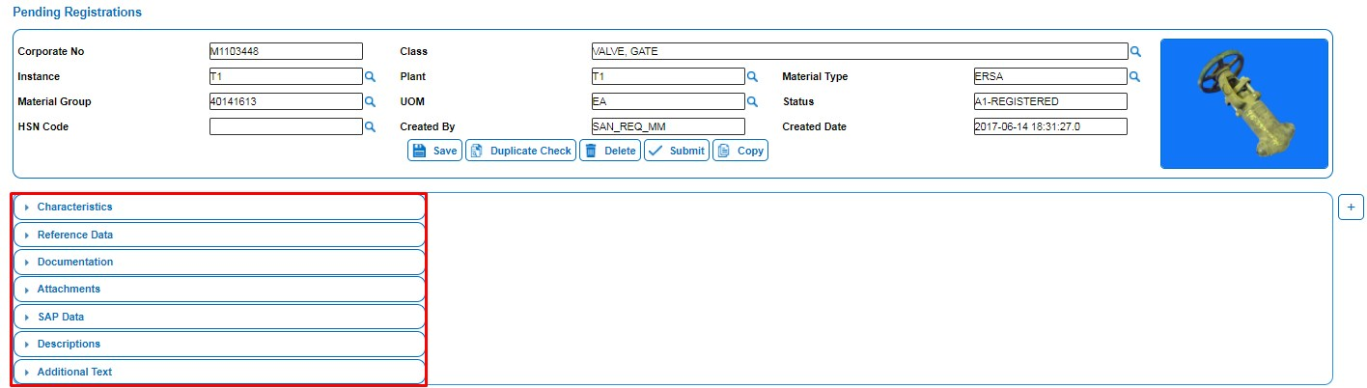

* Submit the request to Approver for approval.
* A pop message will be displayed as “Are you sure you wants to Submit this record” then click on Yes button to submit the record.

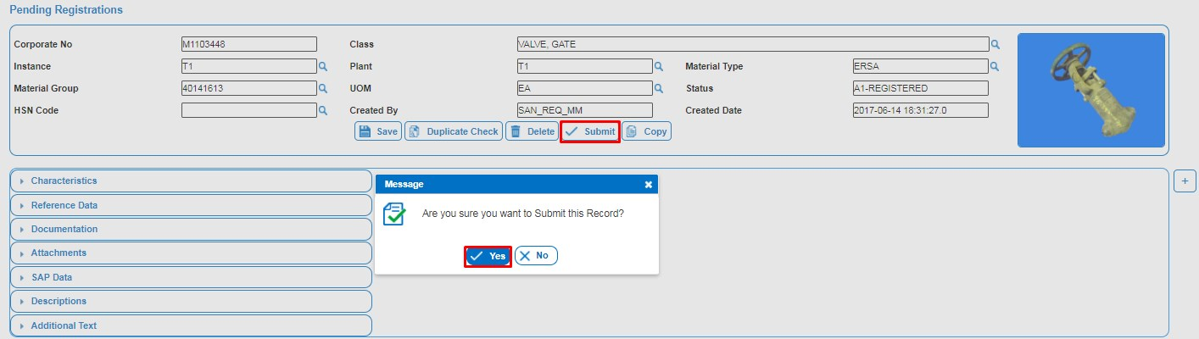

* If the Requestor wants to delete the Registration then click on the Delete button.
* A pop message will be displayed as “Are you sure you wants to Delete this record” then click on Yes button to Delete the record.

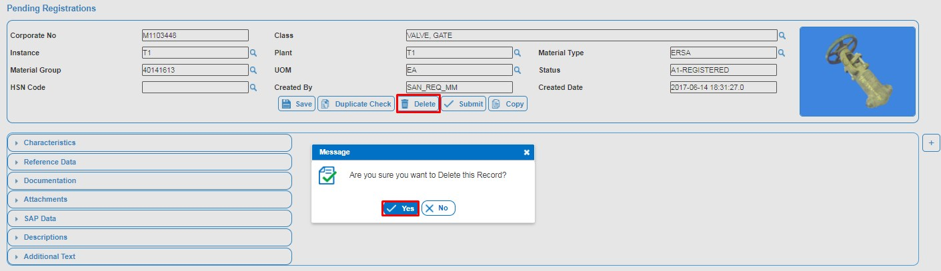

## 2.2 Returned Registrations

Registrations that were rejected by the Approver or Steward are found in the Returned Registrations basket. These Returned requests has to be corrected and then re‐submitted for approval.

Returned records should all have a reason for the rejection. The rejection reason is a guide to what must be corrected before the record will be acceptable for approval.

The rejected record is returned to the originator of the record who has to correct the records and resubmit them for approval.

This basket allows you to Update, Re‐Submit, and to delete the record.

For submitting Returned Registration Material record to Approver comprises the following steps:

* Click on Returned Registrations from Registrations Module.
* Click on Corporate No to retrieve the Material record.

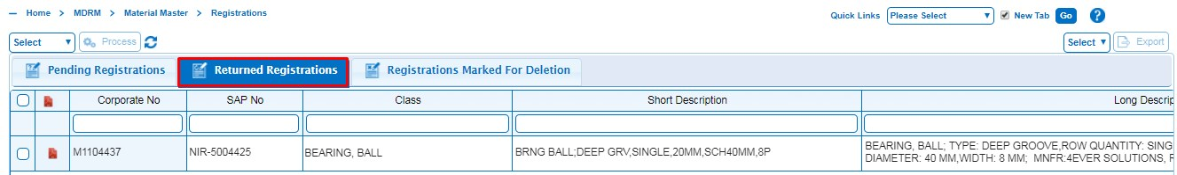

* Make the required changes to the registration as per rejection comment.

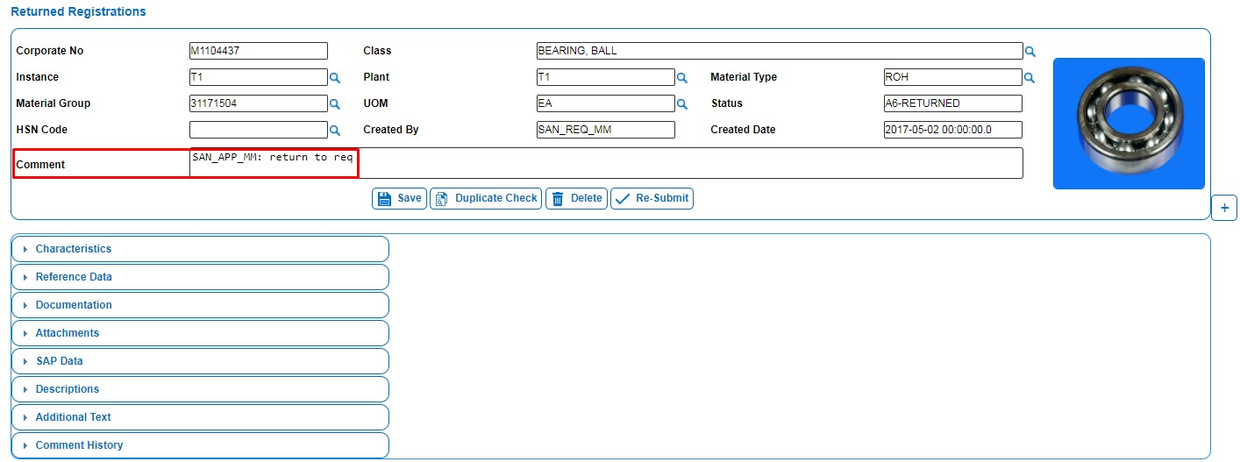

* Re-Submit the Registration to Approver for approval.
* A pop message will be displayed as “Are you sure you wants to Re-Submit this record” then click on Yes button to submit the record.

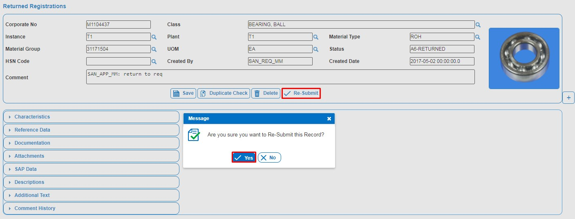

* If the Requestor wants to delete the Registration then click on the Delete button.
* A pop message will be displayed as “Are you sure you wants to Delete this record” then click on Yes button to Delete the record.

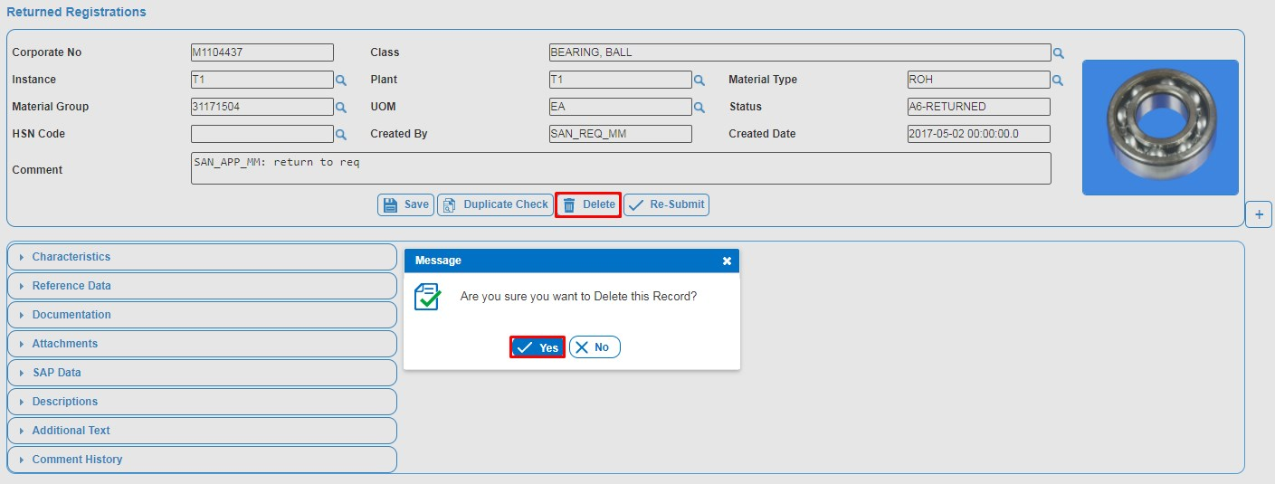

* If you want to delete this material, then it will go to “Registrations Marked for Deletion” Basket.

## 2.3 Registrations Marked for Deletion

This Tab contains deleted Registrations which are deleted by any user. Requestor can re-instantiate deleted Registration which is registered by him/her.

* Click on Registrations Marked for Deletion from Registrations Tab.

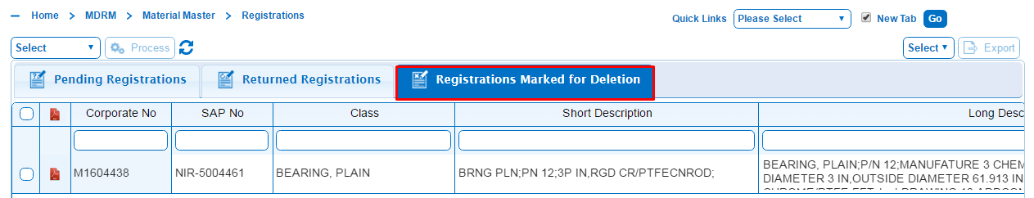

* Select the registration which is to be re-instantiate, Select Re-instantiate and Click on process button.

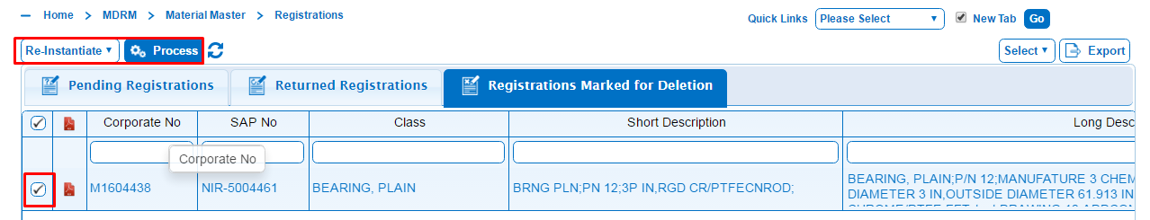

* A pop message will be displayed as “Are you sure you wants to Re-Instantiate this record” then click on Yes button to submit the record.

**EXTENSION REQUEST STATUS FLOW:**



# 3. Extensions

The PiLog - Master Data Record Manager™ (PiLog- MDRM) Requestor - Extensions facility provides Requestor with a utility to request the extension of existing material records to his/her Plant.

### Overview of Material Extensions

It might happen that a material record is required by a particular Plant for use in its SAP system. The user first searches for the record using the PiLog - Master Data Record Manager™(PiLog - MDRM) search facility and might find that the material is not available for his/her own Plant but rather for another Plant. The Plant Extension module is then used to “extend” the material record to his/her Plant for use.

The purpose of “extending” a material record is to add your plant’s information to the material record. This avoids duplicating records in an enterprise’s database and also to save time in obtaining the record for use by your plant.

The Plant Extension function in the PiLog - MDRM allows you to use another plant’s material record for your use. You can edit or add catalogue data that is applicable on plant level for your plant.

This document covers the process to extend a material record to your plant.

**It basically works as follows:**

The Requestor searches and retrieves the required record and extends it to his/her plant. He/she adds or edits the catalogue and SAP data as applicable to his/her plant. He/she then submits the record to the appropriate approver for approval. The Approver checks the validity of the plant extension request. When all is in order, the plant Approver approves the record. The record is now available to the Steward who finally approves and transfers the extension record to the SAP.

**Note**: Only material records with a status of B2-ERP ACCEPTED/C2-RFC STAGED/C2-RFUD STAGED can be retrieved for Plant Extensions. The PiLog - Master Data Record Manager™ (PiLog - MDRM) will inform you that it cannot allow a record to be extended while another business process is in progress. You then have to wait until the process in progress is completed before continuing with the extension.

For the Requestor the process to extend a Material Record comprises the following steps

* Select the Extensions Tab then it will displays list of extensions like New Extension Requests, pending extensions, Returned Extensions and Extensions marked for deletion.

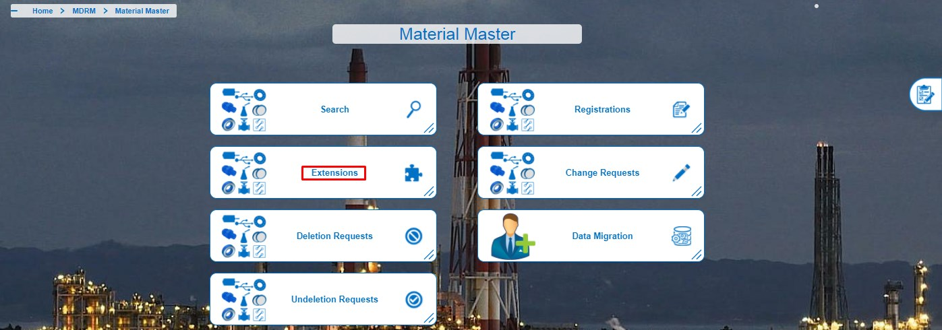

## 3.1 New Extensions Requests

* To Register a New Extension Request click on the New Extension Requests as shown below figure.

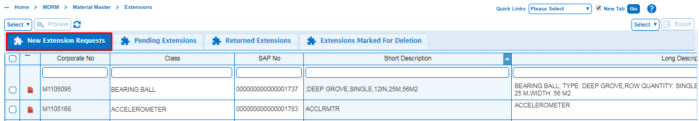

* For New Extension requests click on Displayed New Extension Requests then it will display search criteria to search for existing Material master records.
* You can select any of the search options by clicking on the appropriate tab. It consists of various fields you use to specify the search criteria. You can search on one or more fields.
* After giving sufficient search values as shown in below figure, the results of this search will appear in the Results tab.
* After selecting Corporate No as shown above figure for extensions then it will open New Extension Requests Tab. click on extend button as shown in the below figure.

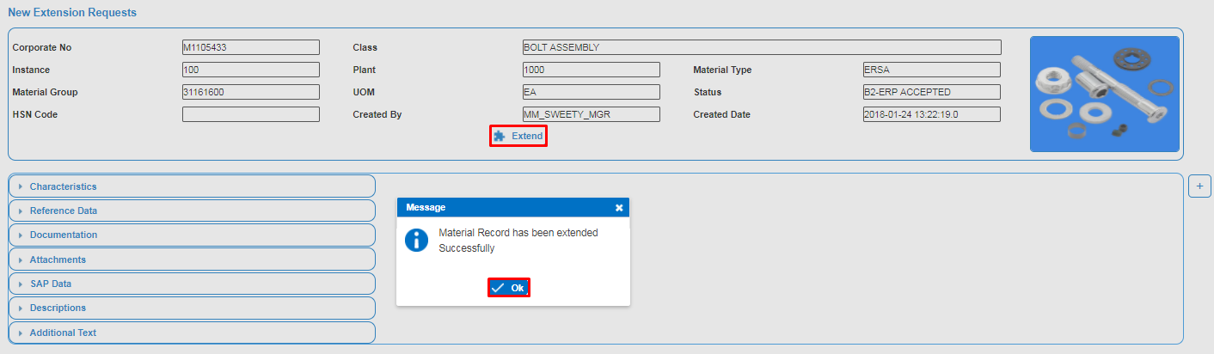

* Pop up message will be displayed as “Material has been extended successfully”. Click on OK button.
* Click on Submit Button as shown in the below figure for submitting the extended Material record to Approver.
* Pop message will be displayed as “Are you sure you wants to submit this record” then click on OK button to submit the record.

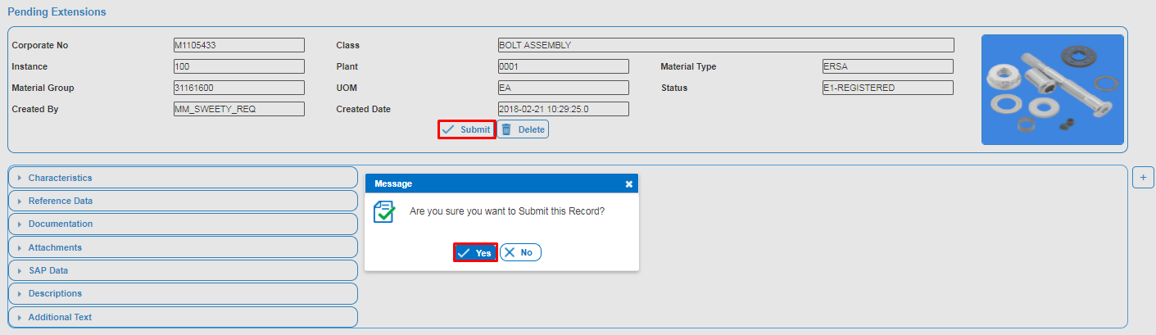

* Pop message will be displayed as “Submitted successfully to Approver”.
* Click on Delete Button as shown in the below figure for Deleting the Material record.
* Pop message will be displayed as “Are you sure you wants to delete this record” then click on OK button to delete the record.

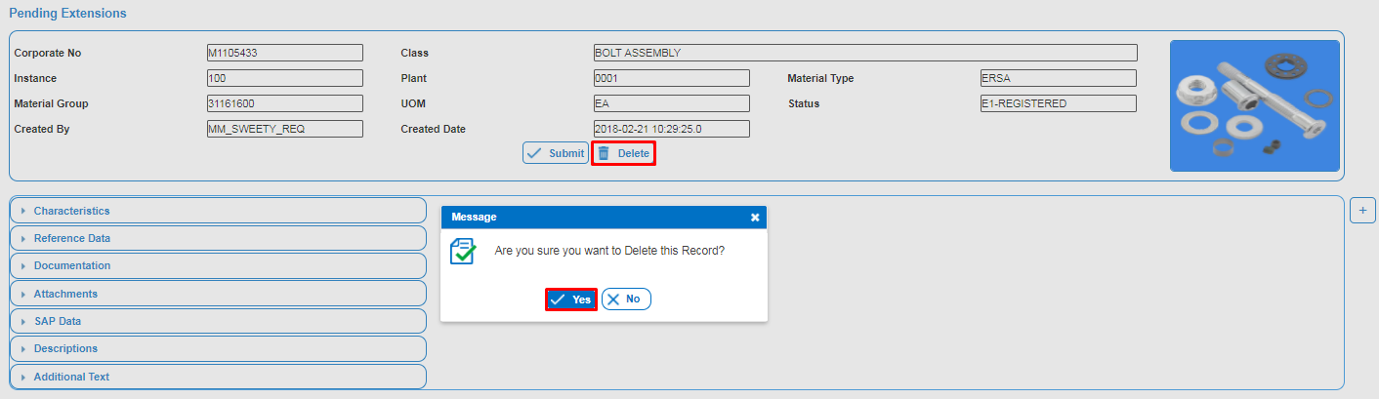

## 3.2 Pending Extensions

The Requestor can retain an Extension Request if he/she is not completely finished editing to complete it later before submitting for approval. The status of the saved record is E1-REGISTERED and can be retrieved again in the Pending Extensions object and be completed.

* To view pending extension registrations click on pending extensions in Extension Tab as shown as in below figure.
* Once user click on pending extensions, then corresponding results will display and select one Material to complete extension registration by clicking on respective corporate number as shown.

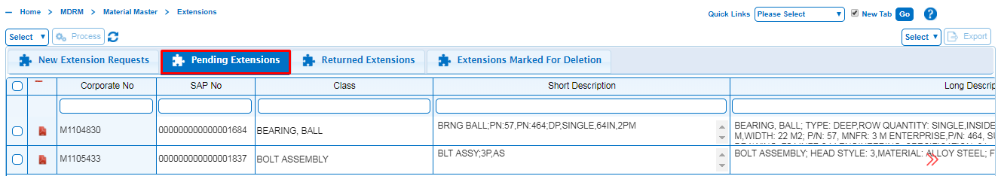

* After populating sufficient information click on submit button to submit the record to Approver for Approval.
* A pop message will be displayed as “Are you sure you wants to submit this record” then click on OK button to submit the record, and then record is submitted to Approver for approval.



Note: If the extended record is not required anymore, click on **Delete** button.

* A pop message will be displayed as “Are you sure you wants to Delete this record” then click on YES button to Delete the record.



* Mention reason for deletion.
* Pop message will be displayed as “Deleted Successfully” then click on OK button to delete the record.
* Now the deleted Material is moved to “extensions marked for deletion basket” and no longer displayed in any pending baskets.

## 3.3 Returned Extensions

This Extension Requests that were rejected by the Approver have to be corrected and then re-submitted for approval. The statuses of returned records are E6-RETURNED and are found in the Returned Extensions object.

Returned records should all have a reason for the rejection. The rejection reason is a guide to what must be corrected before the record will be acceptable for approval.

The rejected record is returned to the originator of the record who has to correct the records and re-submit them for approval.

* Click on Returned Extension as shown in the below figure.
* The returned extension results will appear as shown in the below figure, select the material by clicking on the Material number.

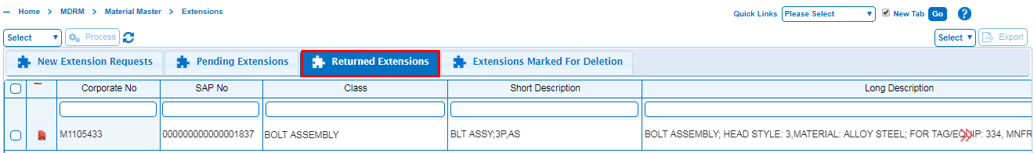

* After modifications done, then submit the Material to Approver by clicking on Re-Submit button as shown.
* A pop message will be displayed as “Are you sure you want to Re-submit this record”. Click on YES then pop message displayed as “submitted successfully to Approver”.

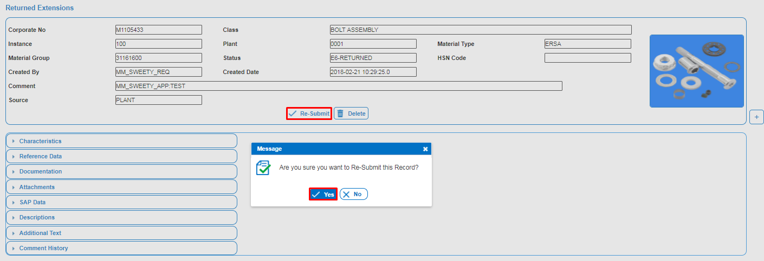

Click on delete button to delete the material record.

* A pop message will be displayed as “Are you sure you want to Re-submit this record”. Click on YES then pop message displayed as “submitted successfully to Approver”.

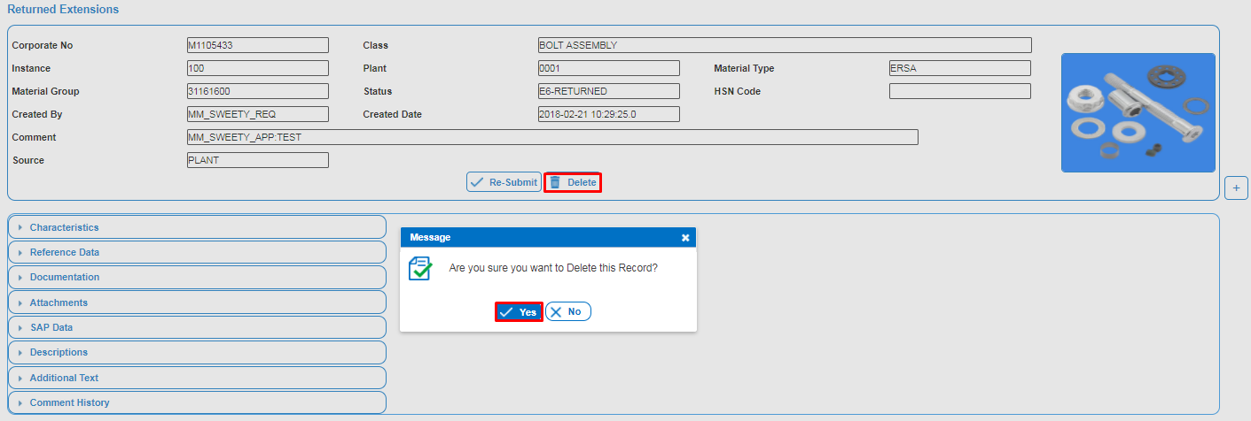

## 3.4 Extensions Marked for Deletion

A Requestor, Approver or Steward can delete an extension request if it is no longer required. The deleted record can be viewed in the Extensions Marked for Deletion object. Deleted extension requests can also be reinstated (un-deleted) again, by the person who originally registered the request.

* Click on Extensions Marked for Deletion from Extensions.

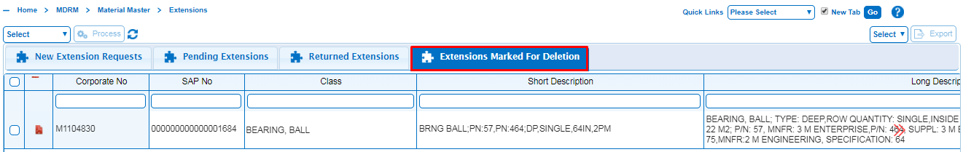

* Select the Request which is to be re-instantiate, Select Re-instantiate and Click on process button.

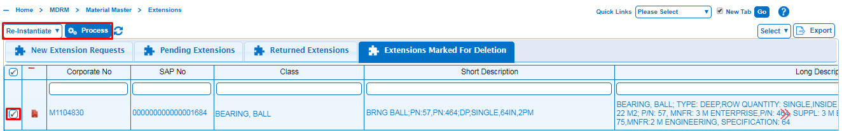

* A pop message will be displayed as “Are you sure you wants to Re-Instantiate this record” then click on Yes button to submit the record.

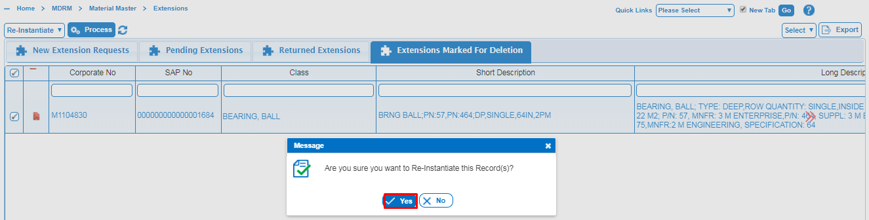

* Click on OK button to instantiated record.

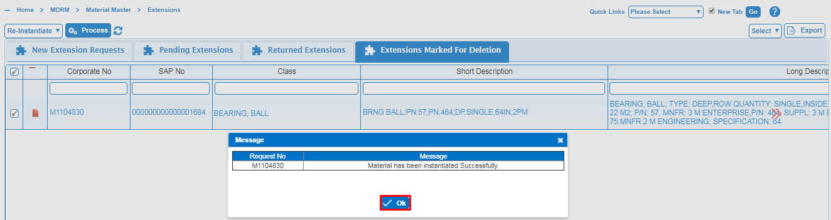

**CHANGE REQUEST STATUS FLOW:**



# 4. Change Requests

The PiLog Master Data Record Manager™ (PiLog - MDRM) Requestor - Change Request facility provides Requestor with a utility to request a change to the Material Information of a material record. Requestor can only request changes to records registered in their own Plants.

### Overview of the Change Request Process

It might happen that Material information are found to be incorrect, more information regarding a Material is required or that certain data might change over time, such as new suppliers with other part numbers etc. This leads to the requirement to change the Material record.

Description Change Request facility provides Requestor with a utility to request to a change or update the description of a material record existing in the SAP.

**Note**: Only material records with a status of B2-ERP ACCEPTED/C2-RFE STAGED/C2-RFUD STAGED can be retrieved for Plant.

* Select the Change Requests Tab then it will displays list of Change Requests like New Change Requests, pending Change Requests, Returned Change Requests and Change Requests marked for deletion.

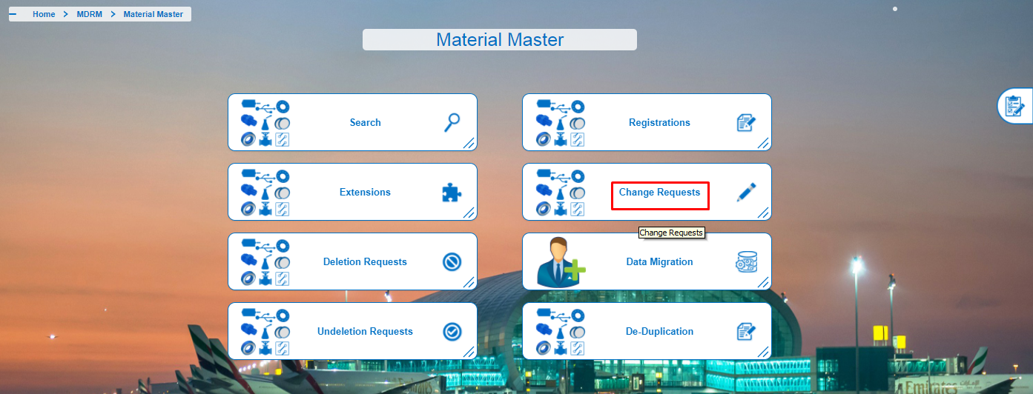

## 4.1 New Change Requests

You first have to retrieve the material record that needs to be changed, using the Change Request Search function. Use the Change button in the retrieved record to access the Change function.

You have to briefly specify the changes or additional requirements in the Change Request Detail field and then make the changes or add data. After the data was changed the record must be submitted for approval. When the request is approved, the changes are transferred to the SAP server.

For the Requestor the process to change Material record comprises the following steps:

* Select New Change Requests from Change Requests.

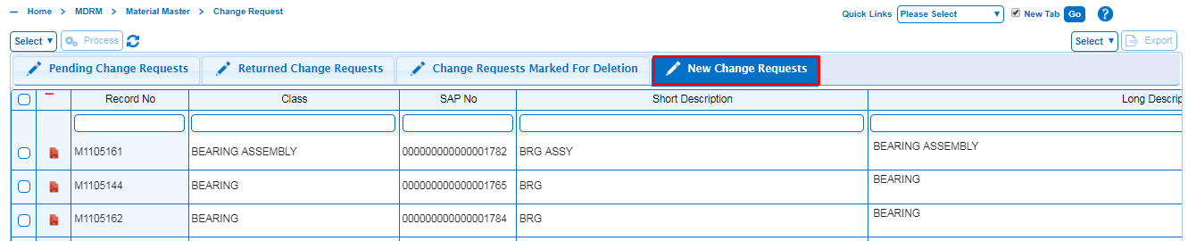

* Search the Material record requiring a change using the Change requests Creation Search.

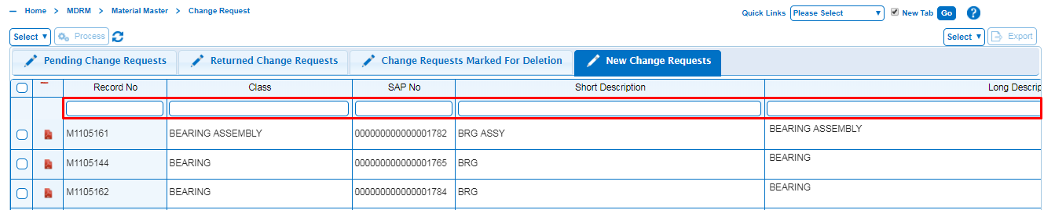

* Click on Record No to retrieve the Material record.

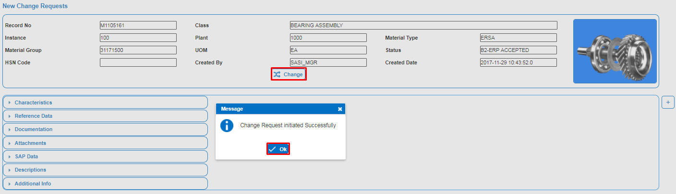

* Click on change button for to create change request.

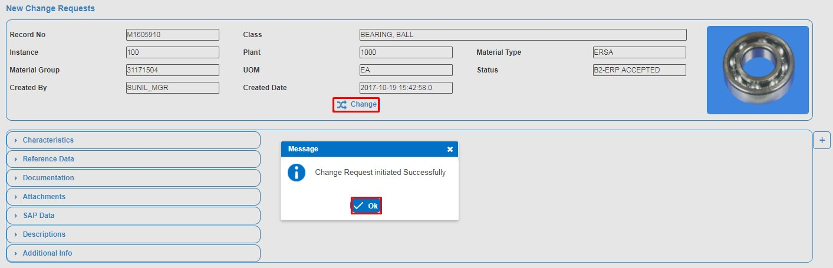

* A pop-up message will be displayed as “Change Request initiated successfully” then click on ok button to change the record.
* Click on Submit to Submit Deletion Requests. A pop-up message will be displayed as “Are you sure you want to Submit this record”.

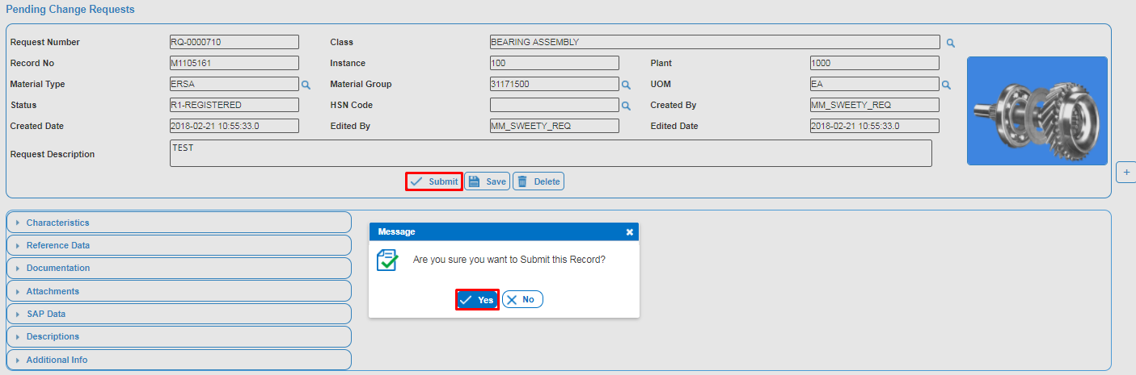

* Pop-up message will be displayed as “Submitted successfully”.
* Click on delete button to delete the Deletion Requests. A pop-up message will be displayed as “Are you sure you want to delete this record”.

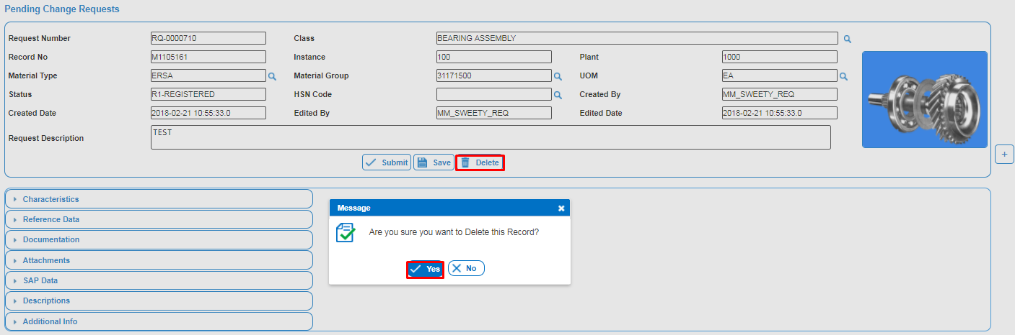

## 4.2 Pending Change Requests

The Requestor can retain a change request if he/she is not completely finished editing the record. The retained record has a status of R1-REGISTERED can be retrieved in the Pending Change Requests object. The record can be completed and submitted for approval.

For Submitting Pending Change request Material record to Approver comprises the following steps:

* Click on Pending Change Requests from Change Requests Tab.
* Click on Request No to retrieve the Material record.

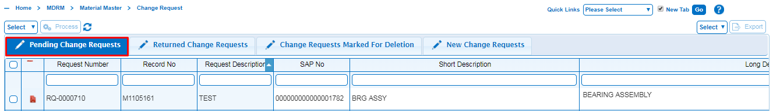

* Submit the request to Approver for approval.
* A pop message will be displayed as “Are you sure you want to submit this Record”. Click on Yes button to submit the Record.

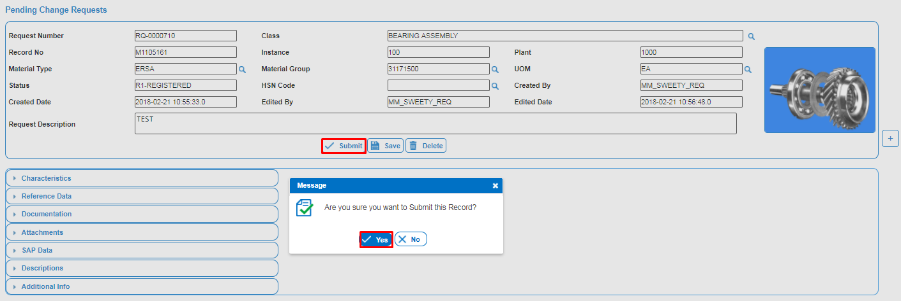

* If the Requestor wants to delete the change request then click on the Delete button.
* A pop message will be displayed as “Are you sure you want to delete this Record”. Then click on Yes button to delete the Record.

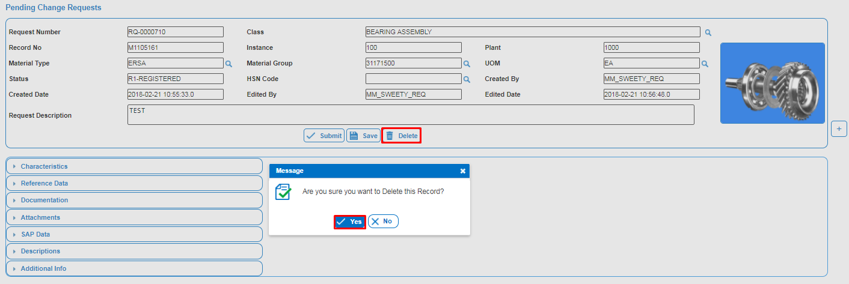

* Pop-up message will be displayed as “Deleted successfully”.

## 4.3 Returned Change Requests

Change Requests that were rejected by the APPROVER/STEWARD/MANAGER have to be corrected and then re-submitted for approval. The statuses of returned records are R6- RETURNED and are found in the Returned Change Requests object.

Returned records should all have a reason for the rejection. The rejection reason is a guide to what must be corrected before the record will be acceptable for approval.

The rejected record is returned to the originator of the record who has to correct the records and re-submit them for approval.

For submitting Returned change request Material record to Approver comprises the following steps:

* Click on Returned Change Requests from Change Requests Tab.
* Click on Request No to retrieve the Material record.

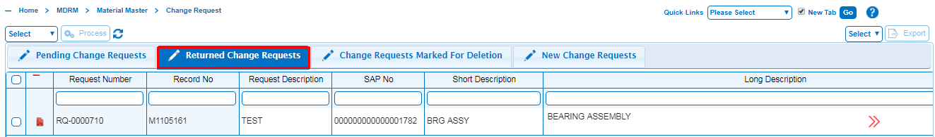

* Re-submit the request to Approver for approval.
* A pop-up message will be displayed as “Are you sure you wants to Re-Submit this record” then click on yes button to Submit the record.

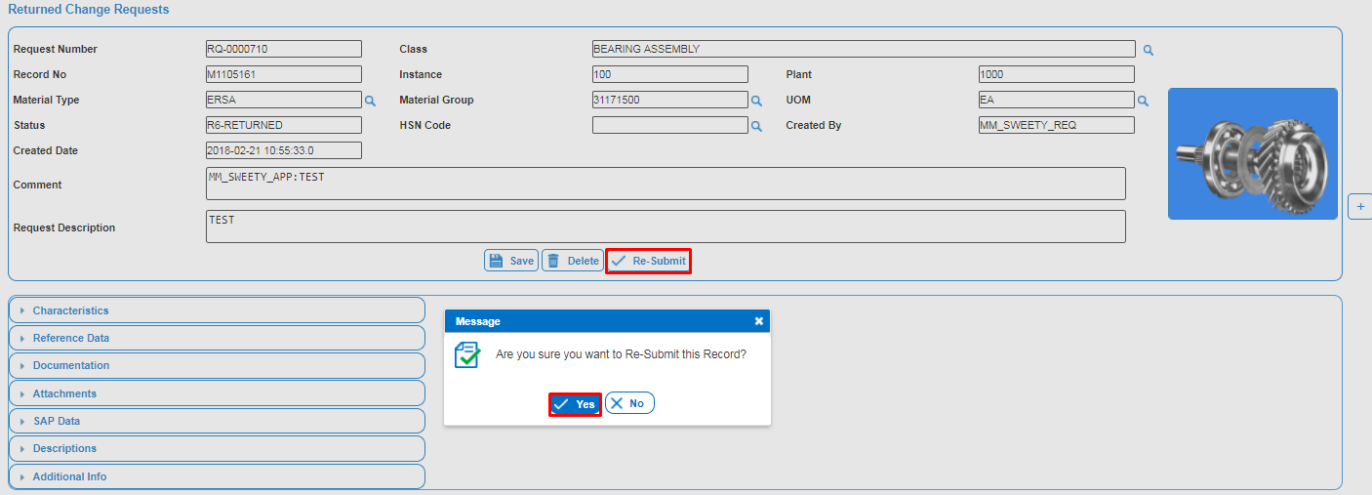

* If the Requestor wants to delete the change request then click on the Delete button.
* A pop-up message will be displayed as “Are you sure you wants to Delete this record” then click on yes button to Delete the record.

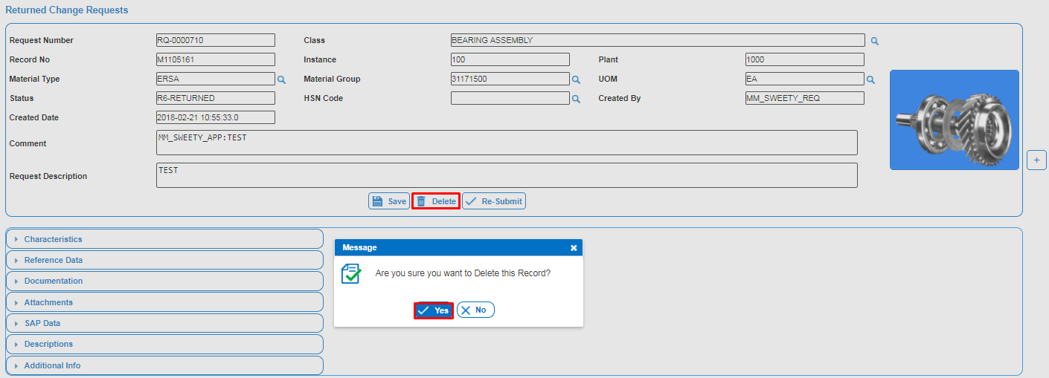

## 4.4 Change Requests Marked for Deletion

A Requestor, Approver or Steward can delete a change request if it is no longer required. The deleted record can be viewed in the Change Requests Marked for Deletion object, but cannot be re-instantiated. A new request needs to be registered if it is required.

* Click on Change Requests Marked for Deletion from Change Requests Tab.

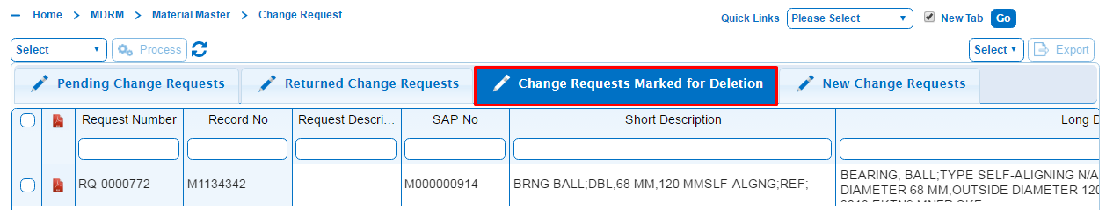

* Select the Request Number which is to be re-instantiate, Select Re-instantiate and Click on process button.

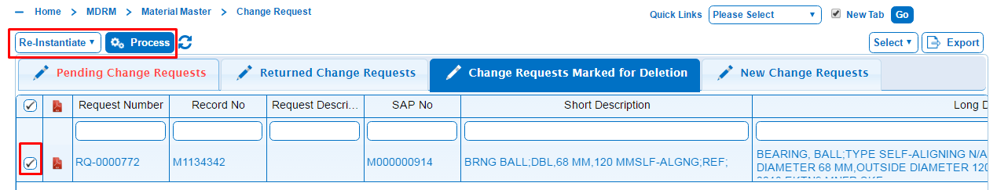

* A pop message will be displayed as “Are you sure you wants to Re-Instantiate this record” then click on Yes button to re-instantiate the record.

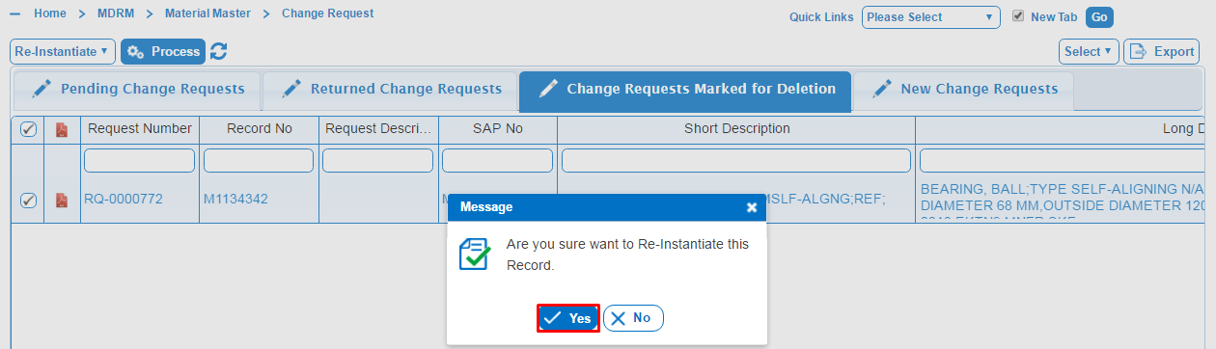

* Click on OK button to instantiated record.

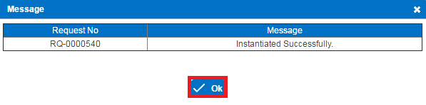

**DELETION REQUEST STATUS FLOW:**



# 5. Deletion Requests

The PiLog Master Data Record Manager (MDRM) Requestor - Deletion Request facility provides Requestor with a utility to request the deletion of a material record in the SAP for their plant.

It might happen that a material record is no longer required for any number of reasons. These records can be flagged for deletion in the SAP. These records will only be flagged as deleted and will not be permanently destroyed. Deleted records can be un-deleted again when needed.

**Note**: Only material records with a status of B2-ERP ACCEPTED/C2-RFC STAGED/C2-RFE STAGED/C2-RFUD STAGED can be retrieved for Plant.

A Requestor can request the deletion of a material record.

## 5.1 New Deletion Requests

* Select the Deletion Requests Tab then it will displays list of Deletion Requests like New Deletion Requests, pending Deletion Requests, Returned Deletion Requests and deletion Requests marked for deletion.

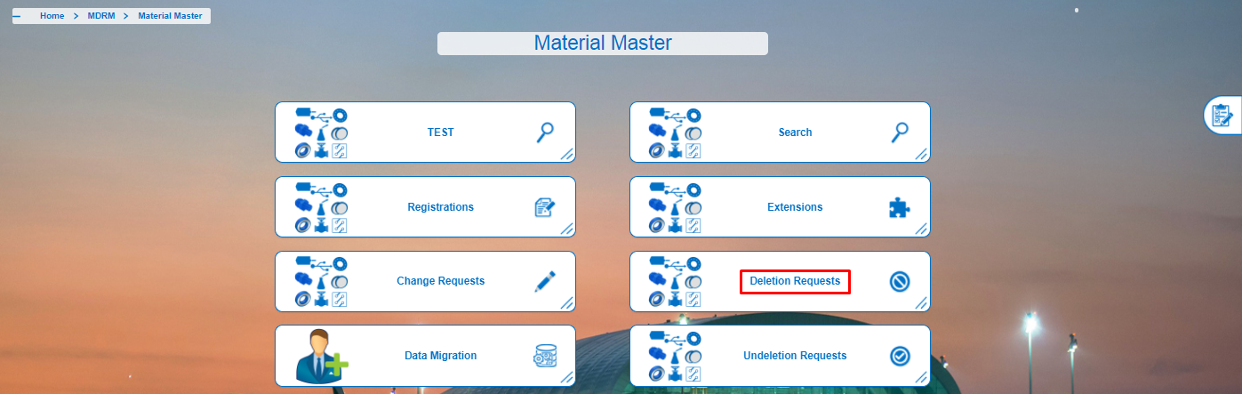

* Click on New Deletion Requests from Deletion Requests Tab.
* Click on Record No to retrieve the Material record.

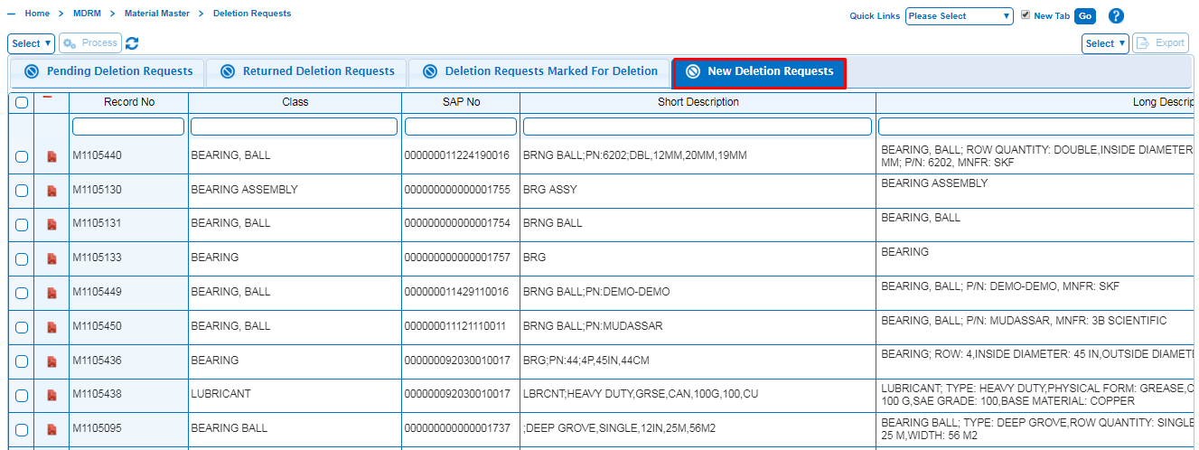

* Click on Delete Requests. A pop-up message will be displayed as “Deletion Requests has been initiated successfully” then click on ok button.

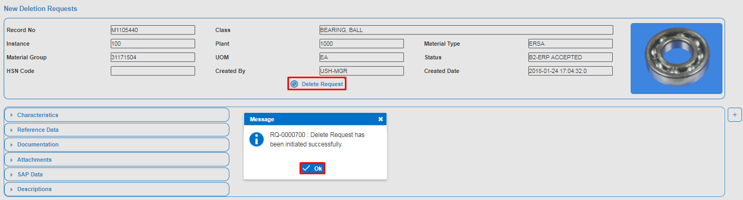

* Click on Submit button to Submit Deletion Requests to the Approver. A pop-up message will be displayed as “Are you sure you want to Submit this record”.

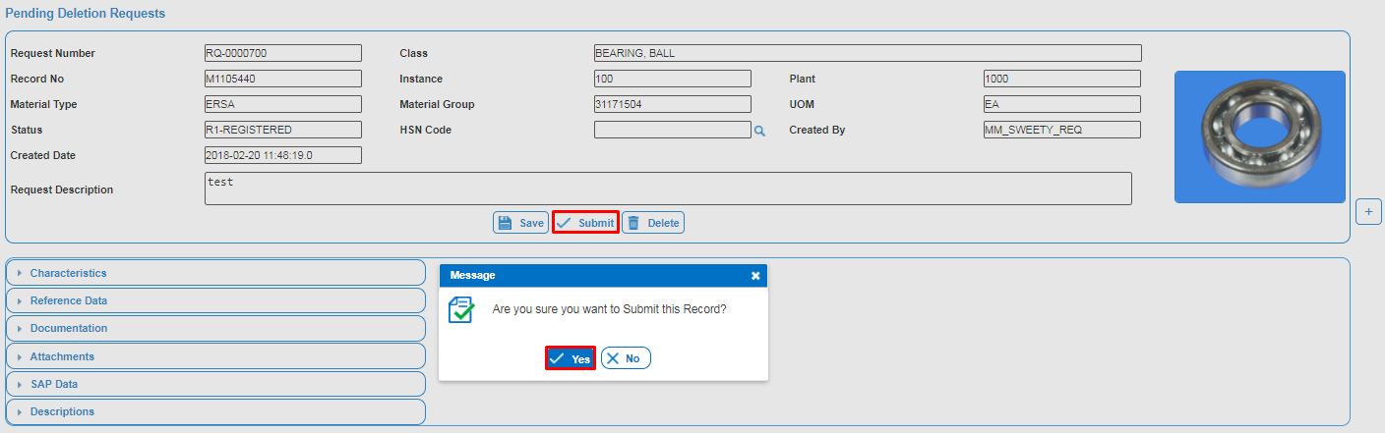

* Click on Delete button to delete Deletion Requests. A pop-up message will be displayed as “Are you sure you want to delete this record”.

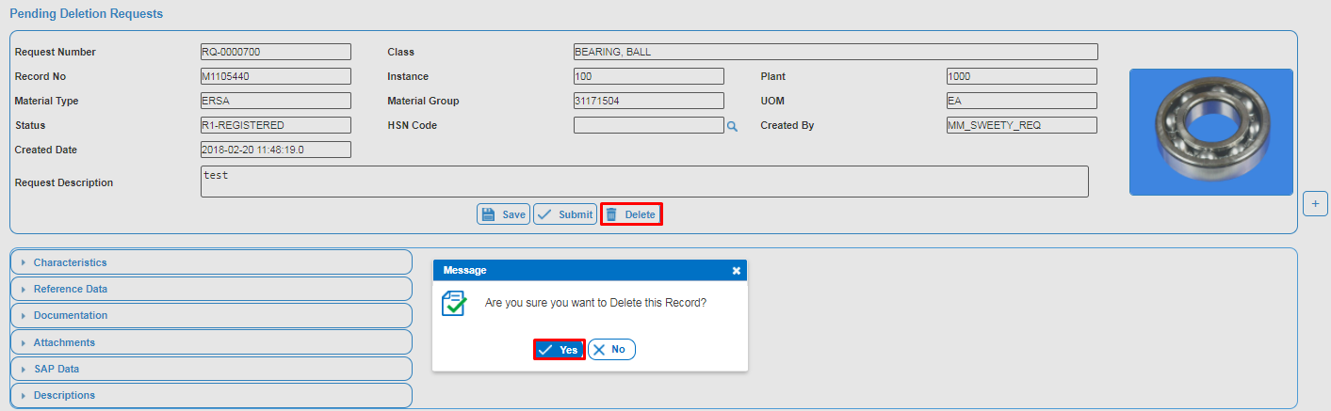

## 5.2 Pending Deletion Requests

The Requestor can retain an SAP Deletion Request if he/she is not ready to submit it yet. The request can be revised later before submitting it for approval. The request can also be deleted. The status of the saved record is R1-REGISTERED and can be retrieved again in the Pending Deletion Requests object.

For Submitting Pending Deletion request Material record to Approver comprises the following steps:

* Click on Pending Deletion Requests from Deletion Requests Tab.
* Click on Request no to Retrieve the Material record.

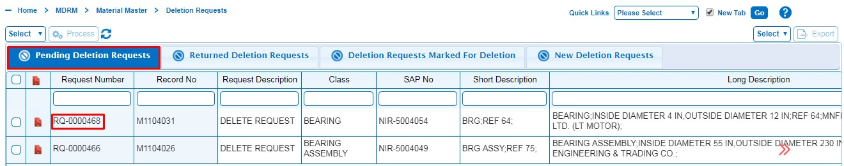

* Click on Submit button to submit the Record. A pop-up message will be displayed as “Are you sure you want to Submit this record” and then Click on Yes button.

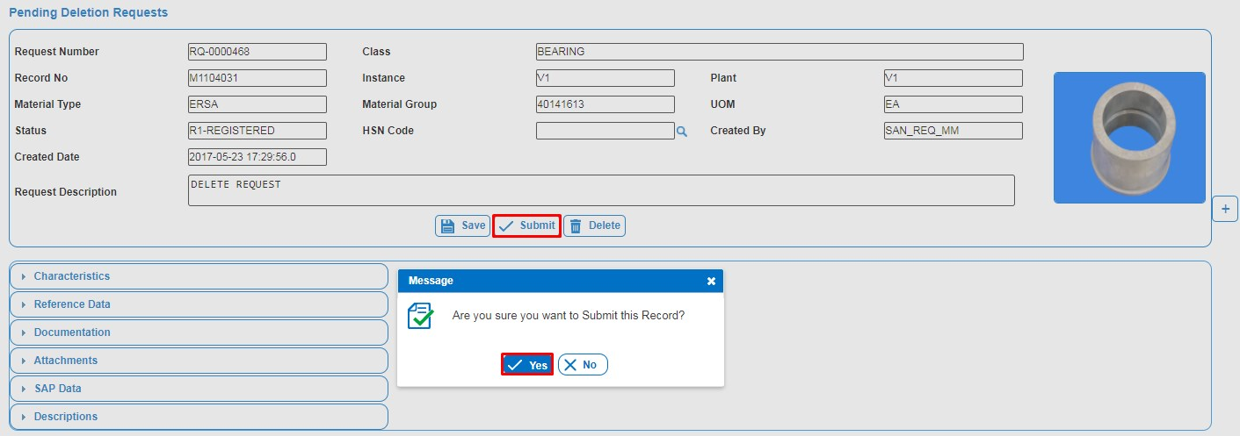

* If the Requestor wants to delete the Deletion request. Click on the Delete button then a pop-up message will be displayed as “Are you sure you want to Delete this Record”.
* Click on Yes button to delete the record.

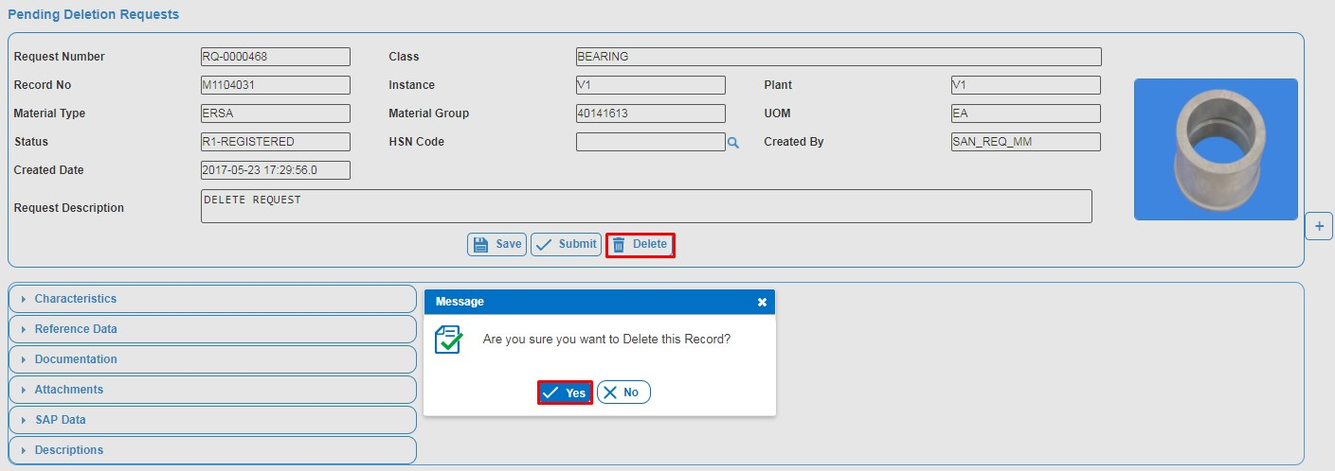

## 5.3 Returned Deletion requests

Deletion Requests that were rejected by the Approver have to be reviewed and then re-submitted for approval. The statuses of returned records are R6-RETURNED and are found in the Returned Deletion Requests object.

Returned records will have a reason for the rejection. The rejection reason is a guide to what must be corrected before the record will be acceptable for approval.

For submitting Returned Deletion request Material record to Approver comprises the following steps:

* Click on Returned Deletion Requests from Deletion Requests Tab.
* Click on Request No to retrieve the Material record.

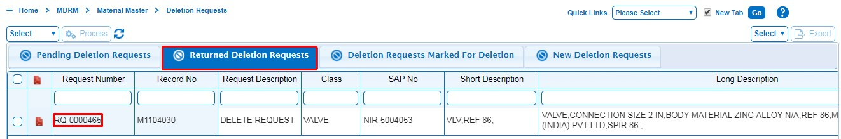

* Make the required changes to the Material record as per rejection comment. Re-submit the request to Approver for approval.

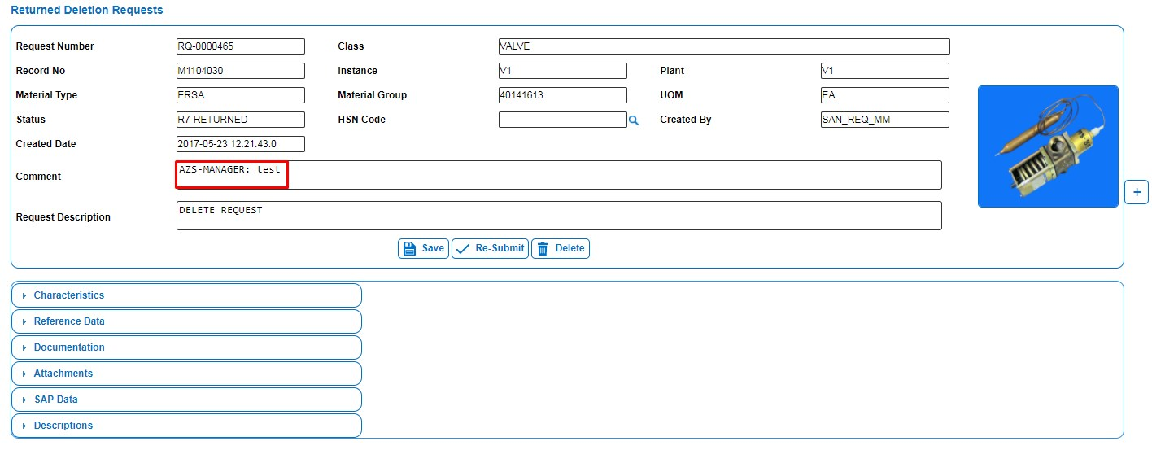

* A pop-up message will be displayed as “Are you sure you wants to Submit this record” then click on yes button to Submit the record.

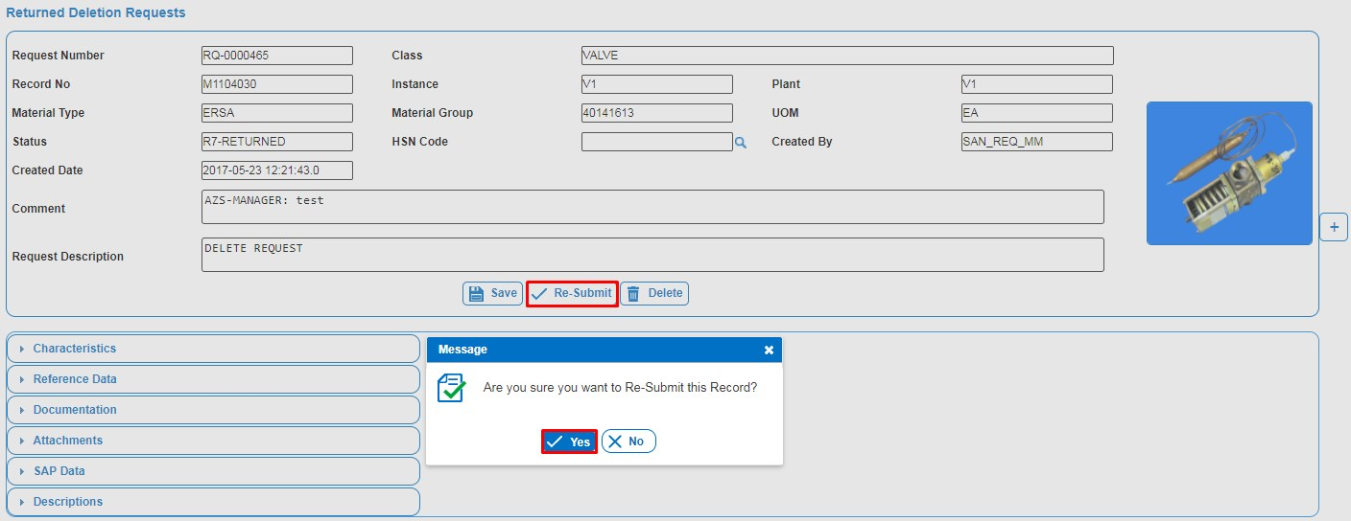

* If the Requestor wants to delete the change request then click on the Delete button.

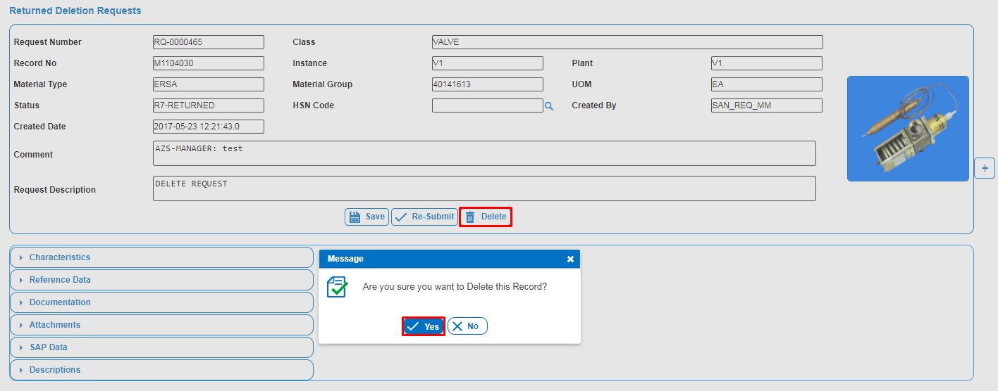

## 5.4 Deletion Requests Marked for Deletion

Deletion Requests that were deleted by the Requestor, Approver and Steward can be viewed in the Deletion Requests Marked for Deletion. Requestor can re-instantiate deleted Request which is registered by him/her.

* Click on Deletion Requests Marked for Deletion from Deletion Requests Tab.

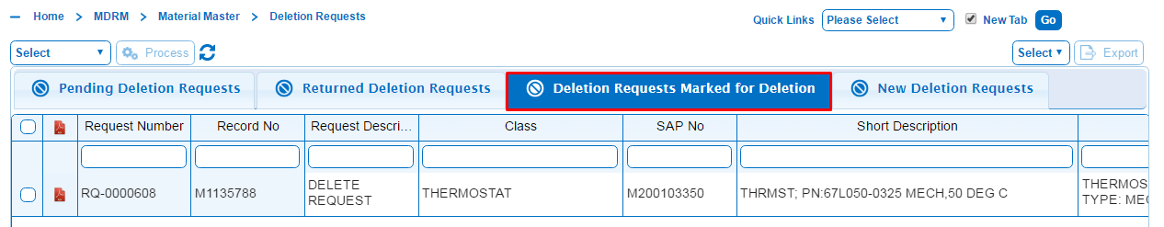

* Select the Request Number which is to be re-instantiate, Select Re-instantiate and Click on process button.

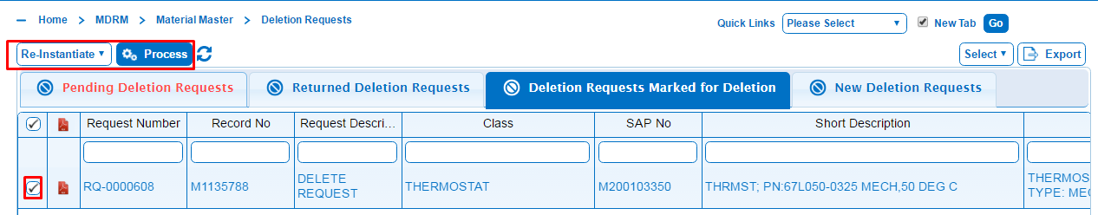

* A pop message will be displayed as “Are you sure you wants to Re-Instantiate this record” then click on Yes button to re-instantiate the record.

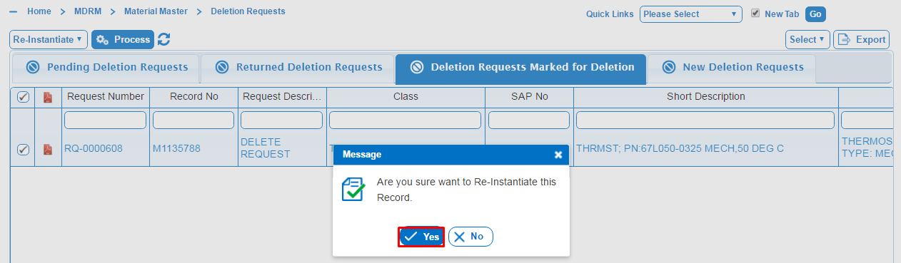

* Click on ok to Instantiated.

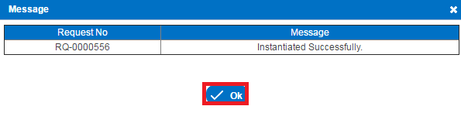

**UNDELETION REQUEST STATUS FLOW:**



# 6. Undeletion Requests

The PiLog Master Data Record Manager (MDRM) Requestor - Undeletion Request facility provides Requestor with a utility to request the Undeletion of a material record in the SAP for their plant.

It might happen that a material record is no longer required for any number of reasons. These records can be flagged for deletion in the SAP. These records will only be flagged as deleted and will not be permanently destroyed. Deleted records can be un-deleted again when needed.

**Note**: Only material records with a status of C2-RFD STAGED can be retrieved for Plant.

A Requestor can request the Undeletion of a material record.

* For the Requestor the process to Undelete Material record comprises the following steps:

## 6.1 New Undeletion Requests

* Select the Undeletion Requests Tab then it will displays list of Undeletion Requests like New Undeletion Requests, pending Undeletion Requests, Returned Undeletion Requests and Undeletion Requests marked for deletion.

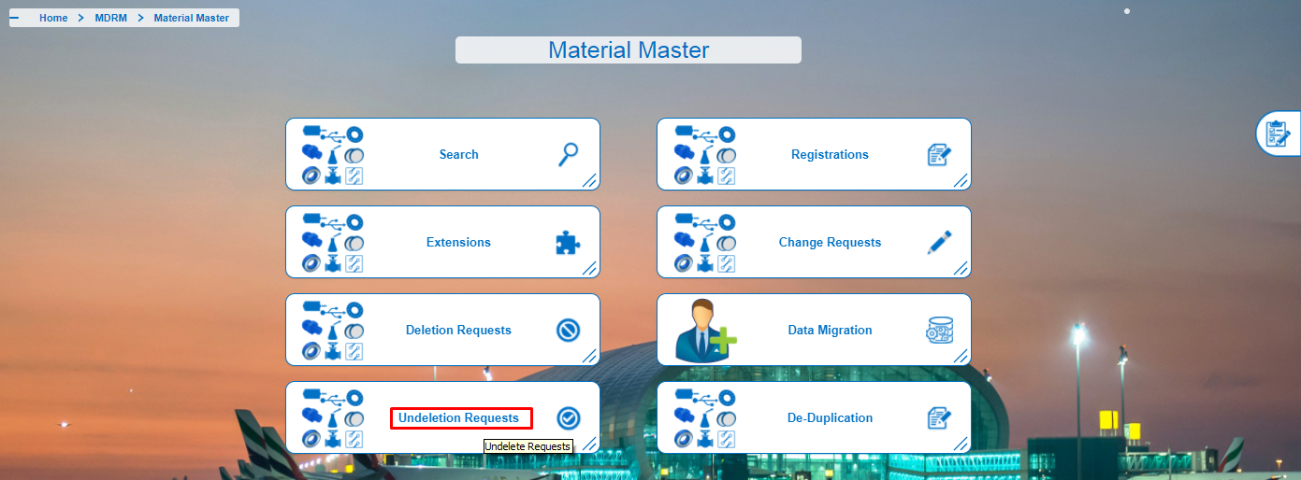

* Click on New Undeletion Requests from Undeletion Requests Tab.
* Click on Record No to retrieve the Material record.

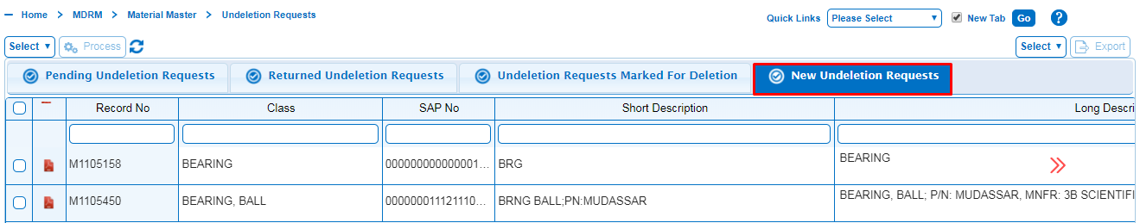

Click on Undeletion request to Create a Material record.

* A pop-up message will be displayed as “Undelete Requests Created Successfully” then click on ok button to delete the record.

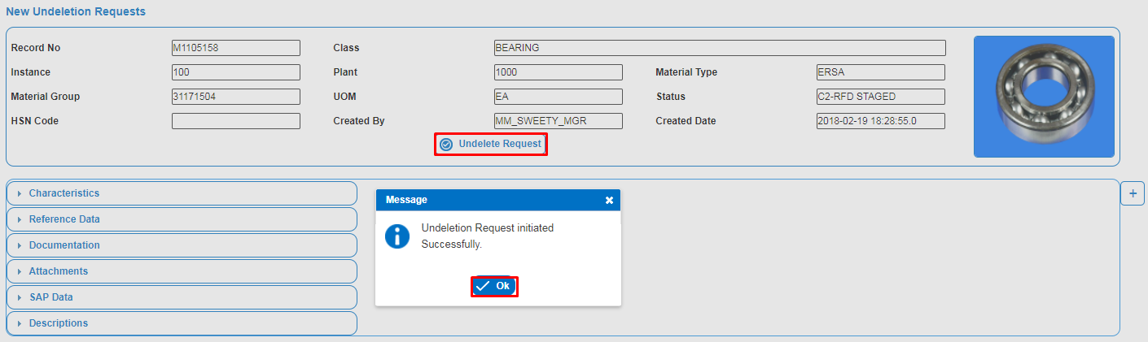

* Click on Submit button to Submit Undeletion Requests. A pop-up message will be displayed as “Are you sure you want to Submit this record”.

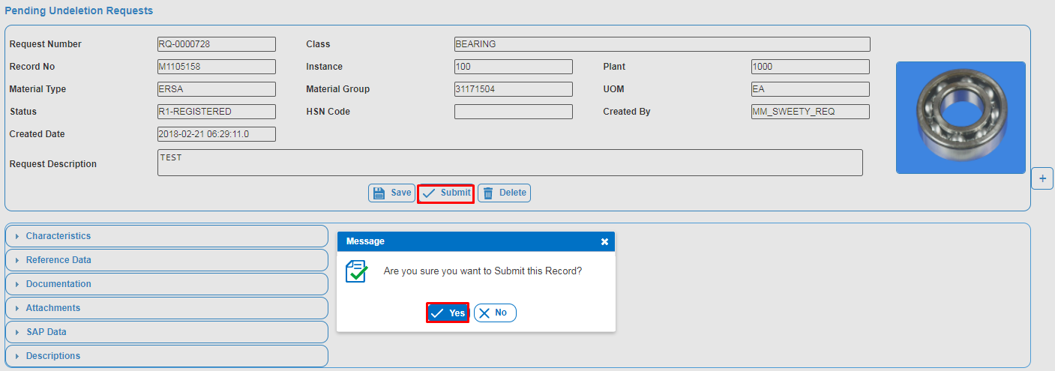

* Click on Delete button to Delete Material Record. A pop-up message will be displayed as “Are you sure you want to Delete this record”.

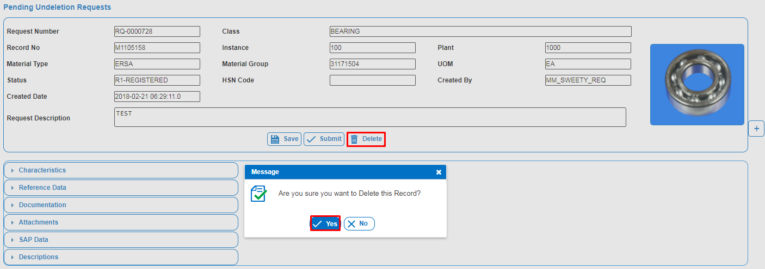

## 6.2 Pending Undeletion requests

The Requestor can retain a Undeletion Request if he/she is not ready to submit it yet. The request can be revised later before submitting it for approval. The request can also be deleted. The status of the saved record is R1-REGISTERED and can be retrieved again in the Pending Undeletion Requests object.

For Submitting Pending Undeletion request Material record to Approver comprises the following steps:

* Click on Pending Undeletion Requests from Undeletion Requests Tab.
* Click on Request No to Retrieve the Material record.

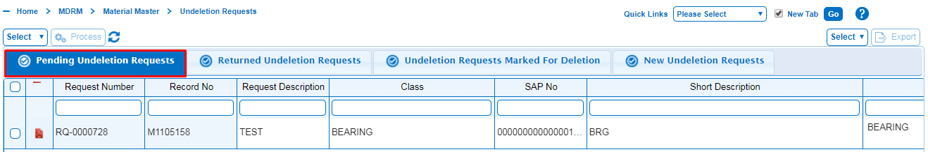

* Click on Submit button to submit the Record. A pop-up message will be displayed as “Are you sure you want to Submit this record” and then Click on Yes button.



* If the Requestor wants to delete the Undeletion request. Click on the Delete button then a pop-up message will be displayed as “Are you sure you want to Delete this Record”.



* Click on Yes button to delete the record.

## 6.3 Returned Undeletion requests

Undeletion Requests that were rejected by the Approver have to be reviewed and then re-submitted for approval. The statuses of returned records are R6-RETURNED and are found in the Returned Undeletion Requests object.

Returned records will have a reason for the rejection. The rejection reason is a guide to what must be corrected before the record will be acceptable for approval.

For submitting Returned Undeletion request Material record to Approver comprises the following steps:

* Click on Returned Undeletion Requests from Undeletion Requests Tab.
* Click on Request No to retrieve the Material record.

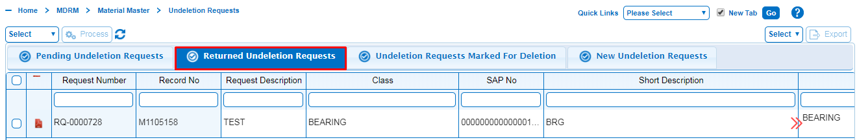

* Make the required changes to the Material record as per rejection comment. Re-submit the request to Approver for approval.

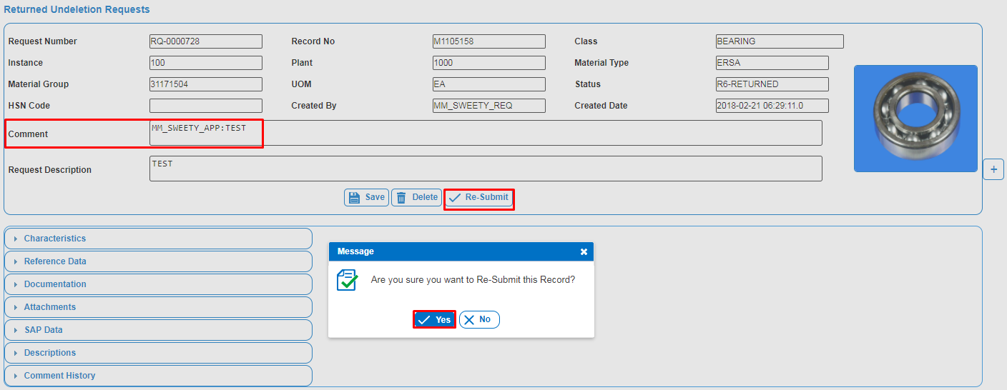

* A pop-up message will be displayed as “Are you sure want to Re-submit this record” then click on yes button to Re-Submit the record.
* If the Requestor wants to delete the change request then click on the Delete button.
* A pop-up message will be displayed as “Are you sure want to delete this record” then click on yes button to Delete the record.

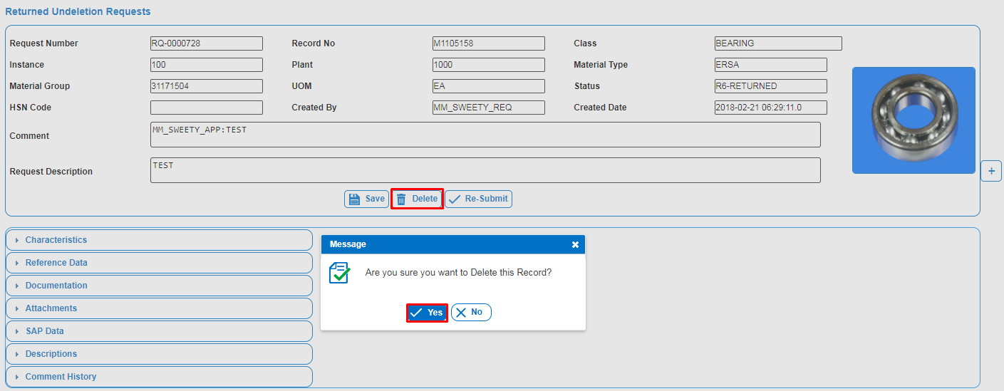

## 6.4 Undeletion Requests Marked for Deletion

Undeletion Requests that were deleted by the Requestor, Approver and Steward can be viewed in the Undeletion Requests Marked for Deletion. Requestor can re-instantiate deleted Request which is registered by him/her.

* Click on Undeletion Requests Marked for Deletion from Undeletion Requests Tab.
* Select the Request Number which is to be re-instantiate, Select Re-instantiate and Click on process button.
* A pop message will be displayed as “Are you sure wants to Re-Instantiate this record” then click on Yes button to re-instantiate the record.
* Click on ok to Instantiated.

Lean data governance is a Simplified version of MDM with enriched User Experience, hosted on Cloud platform with high availability

To choose the right version/plan among On-Cloud versus On-Premise 'Choose the Best Plan' to help/guide what's best for the organization, navigate through the guide to get assistance on choosing the right version/plan

Customizing a lean data governance is only for Enterprise On-Cloud model

Data in the pilog on-cloud lean data governance is 100% safe

Amount fee will be refunded into the Bank account within 3 working days on quitting the users

Yes, entire data will be shared in xlsx files and then dropped 30 days post subscription expiry date once the subscription expired.

Pilog lean data governance have four different membership or plans available like: Basic, Professional, Enterprise (on cloud), Enterprise (on premise)

Basic membership: Basic membership in lean data governance is ideal for a very small business. It includes only one domain. It includes access to 5 users. Basic plan or membership price is $99 per user.

Professional Membership: Professional Membership is ideal for a medium business. It includes only three domain. It includes access to 20 users. Professional membership costs $199 per user.

Enterprise on cloud: Enterprise on-cloud membership is also available for unlimited domains. It includes access to 100 users.

Enterprise on premise: Enterprise on-premise Membership is ideal for a extra large enterprise businesses. It is available for unlimited domains. It includes access to 100 or more users.

|  |  |  |  |
| --- | --- | --- | --- |
| **topic name** | **basic plan** | **professional plan** | **enterprise plan** |
| plan duration | Annually | Annually | Annually |
| No. of Users | 5 | 20 | 100 |
| No. of Item Requests/per year | 2000 | 5000 | 10000 |
| Smart Search [Fuzzy, Reference, Classification & Free Text] | yes | yes | yes |
| Parametric Search | yes | yes | yes |
| Category & UNSPSC Search | yes | yes | yes |
| Category & UNSPSC Search | yes | yes | yes |
| create | yes | yes | yes |
| change | yes | yes | yes |
| extend | no | yes | yes |
| delete | yes | yes | yes |
| undelete | yes | yes | yes |
| Superseded Materials | no | no | yes |
| Unsuperseded Materials | no | no | yes |
| eBOM Linking | no | no | yes |
| fBOM Linking | no | no | yes |
| mBOM Linking | no | no | yes |
| Archive Materials | no | no | yes |
| Unarchive Materials | no | no | yes |
| No. of MM Taxonomy Templates | 100 | 400 | 1200 |
| No. of PPR Searches | 2000 | 5000 | 10000 |
| Automated Mapping linked to classification | yes | yes | yes |
| Description Configuration UI [User Defined] | no | yes | yes |
| Deduplication Configurable Type 1 [Reference Types] | no | yes | yes |
| Deduplication Descriptive Type2 [Class+Char+Values] | yes | yes | yes |
| References Data Management - One To Many | yes | yes | yes |
| Multi-Lingual Description Generation | no | no | yes |
| Standard List of Characteristic Values [As Dropdown Values (LOVs) Via PiLog APIs] | yes | yes | yes |
| Dictionary / Taxonomy Manager UI | no | yes | yes |
| New Template Request from PiLog Cloud | no | yes | yes |
| Change Template Request from PiLog Cloud | no | yes | yes |
| Customized Taxonomy / Dictionary (User defined) | no | yes | yes |
| Preferred UOM [Characteristic Level] | yes | yes | yes |
| Image(s) as Attachment | yes | yes | yes |
| Drawing(s) / Document(s) as Attachment | yes | yes | yes |
| UNSPSC Version 21 Classification | yes | yes | yes |
| Class - UOM - Material Group [UNSPSC] Mapping | yes | yes | yes |
| User defined Terminology Abbreviations [Class, Characteristics, Values & UOMs] | no | no | yes |
| Pre-defined Terminology Abbreviations [Class, Characteristics, Values & UOMs] | yes | yes | yes |
| Standard Description Generator included | yes | yes | yes |